

**India SDG Dashboard**

Software Requirements Specification

Revision History 3

Chapter I: Introduction 4

1. Purpose of the system 4

2. Document Convention 4

3. Intended Audience and Reading Suggestions 4

4. System Scope 5

4.1 Implementation Use Case 9

4.2 Salient Features 10

4.3 Out of Scope 12

4.4 System Data Structure 12

4.5 Geographical Coverage Entities 14

System Chart 15

5. System Security 16

6. References 16

Chapter II: Overall Description 17

1. System Perspective 17

2. System Functions 18

3. User Roles 20

4. Operating Environment 21

5. Design and Implementation Constraints 21

6. User Documentation 22

7. Assumptions and Dependencies 22

8. External Interface Requirements 22

Chapter III: System Features 24

1. User Interface 24

1.1 Home page 25

1.2 Overview 25

1.3 India 26

2. Data Manager 34

2.1 Login 34

2.2 Data Summary 35

2.3 Data Template 35

2.4 Data Entry / Edit 42

2.5 Data Approve / Publish 42

2.6 Log 43

2.7 SDMX 44

Other Nonfunctional Requirements 45

Performance Requirements 45

Safety Requirements 45

Security Requirements 45

Software Quality Attributes 45

Business Rules 46

Other Requirements 46

Annexure A: Entity-Relation Diagram (ERD) 47

Annexure B: State Transition Diagram 47

Data Manager 48

User Interface 49

Annexure C: Data Dictionary 50

Annexure D: Data Flow Diagrams (DFD) 58

Level 0 58

Level 1 59

Level 2 – Data Manager 60

Level 2 – User Interface 61

Annexure E: System Architecture 62

Annexure F: Software Architecture 63

Annexure G: System Flow Charts 64

User Interface 64

Data Manager 65

Data Manager – Import Area 66

Data Manager – Import Indicator 67

Data Manager – Import Data 68

Data Manager – Import Metadata 69

Data Manager – Import Default Chart Type 70

Data Manager – Data Entry / Edit 71

Data Manager – Data Approve / Publish 72

Annexure H: Data Templates 76

Annexure I: System Screens 79

User Interface 79

Data Manager 84

# Revision History

|  |  |  |  |
| --- | --- | --- | --- |
| **Name** | **Date** | **Reason For Changes** | **Version** |
| iTM | 05 Nov 2019 | The First Draft is created on this date | V1.0 |

# Chapter I: Introduction

## Purpose of the system

The purpose of this document is to provide system requirements specification to develop the India SDG Dashboard. The document provides a detailed explanation of the objectives, scope, modules, features, and functionalities of the application software.

India SDG Dashboard will be developed as a web-based application to store, manage and disseminate SDGs indicators based on data ready to track and monitor for better decision-making.

The major objectives of the system will be:

* To provide a national SDG data portalaligned integrating existing data of the state agencies/departments where possible.
* To develop an online data entry tool with features to manage national SDG indicators and perform data entry and data finalization.
* To create SDG indicators based database guided and owned by the Department of Planning, Economics, and Statistics and other stakeholder departments.
* To develop SDG data portal training materials and to build the capacity of key stakeholders on SDG tracking, monitoring, and reporting.

## Document Convention

This project will be managed using effective frameworks and proven methodologies such as AGILE and PRINCE2, to drive this project to success. This first documentation is the key to the process of software development.

## Intended Audience and Reading Suggestions

This document will be a ready reference for the design and development team to understand the system architecture and scope of the project. This document contains the system scope, overview, and features with system design. The project team can understand the systems architecture by following the Data Flow Diagrams, ER Diagram, System and Software Architecture and System Flow charts provided in this document under Annexures. The development team will follow the wire frames for User Interface design and development, the details of each module is mentioned in this document to guide the logic development.

## System Scope

**SDGs at Global Level**

The Sustainable Development Goals (SDGs) were adopted by all United Nations Member States in 2015 at the 70th session of the United Nations General Assembly (UNGM) as a universal call to action to end poverty, protect the planet and ensure that all people enjoy peace and prosperity by 2030. The 17 SDGs and associated 169 targets are [integrated](https://sdgintegration.undp.org/)—that is, they recognize that action in one area will affect outcomes in others and that development must balance social, economic and environmental sustainability. Countries have the primary responsibility for follow-up and review, at the national level with regard to the progress made in implementing the goals and targets over the next 15 years.

**SDGs at National Level**

India as a Member of [Inter-Agency and Expert Groups on SDGs (IAEG-SDGs)](https://unstats.un.org/sdgs/indicators/indicators-list) adopted a Global Indicator Framework, consisting of 232 unique Indicators. Methodological development of indicators, the establishment of data flow mechanisms, monitoring, and dissemination of data on each of the global indicators in the Global Framework is led by a UN Statistics Division (UNSD). The UNSD requires to involve the National Statistical Offices of the country in the indicator development process.

The Ministry of Statistics and Programme Implementation (MoSPI) has been entrusted with the responsibility of developing the National Indicator Framework (NIF) which will help in monitoring the progress of the SDGs and associated targets. SDG Unit has been created in Social Statistics Division (SSD) of Central Statistics Office with the purpose to perform the following roles and responsibilities relating to SDGs:

* Development of National Indicator Framework in consultation with concerned central ministries/departments.
* Establish coordination mechanism on data-related activities with various line ministries/departments and other data source agencies relating to national as well as global SDG indicators for global SDG monitoring.
* Assisting and building the capacity of statistical institutions at States and UTs levels to adapt NIF and develop their respective State Indicators Framework (SIF).

National Institution for Transforming India (NITI Aayog) has the overall responsibility of SDGs implementation and align government schemes/ programs to SDGs. Thus, NITI Aayog is facilitating and coordinating the implementation of SDGs in the country and also undertaking comparative analysis of SDG achievement in the States and UTs.

The National Indicator Framework (NIF) currently comprises **306 indicators** for different targets and goals. There are certain global indicators for which national indicators have still to be decided on. Below is the number of indicators in NIF grouped by SDGs.

|  |  |
| --- | --- |
| **SDGs** | **# of indicators in NIF** |
| SDG 1 | 19 |
| SDG 2 | 19 |
| SDG 3 | 41 |
| SDG 4 | 20 |
| SDG 5 | 29 |
| SDG 6 | 19 |
| SDG 7 | 5 |
| SDG 8 | 40 |
| SDG 9 | 18 |
| SDG 10 | 7 |
| SDG 11 | 16 |
| SDG 12 | 17 |
| SDG 13 | 4 |
| SDG 14 | 13 |
| SDG 15 | 21 |
| SDG 16 | 18 |
| SDG 17 | 0 |
| **Total** | **306** |

**SDGs at State Level**

The States should develop their own State Indicator Framework (SIF) based on their individual critical development priorities, data requirements, available infrastructure, and resources. States may require more disaggregated data not only vertically (districts, sub-districts and lower level) but also horizontally (sex, classes, social groups, marginalized population groups – persons with disabilities, elderly, children, among others). The State Indicator Framework must meet the state requirements of SDGs monitoring with suitable provisions for its refining, modification, and improvements over time.

MoSPI has suggested the following guidelines to develop SIFs:

* To develop SIFs in a participatory manner
* SIF should complement the overall State development strategy
* SIF should be aligned to the NIF

The State Planning Commission (SPC) in Madhya Pradesh developed the state SDG Action Plan that comprises of SDG indicators and their targets of 2020, 2025 and 2030. This document has 3 volumes. Volume I consist of **62 priority indicators** formulated by NITI Aayog as part of the SDG India Index 2018 report and Volume II Part A covers the **306 indicators** from the National Indicator Framework developed by MoSPI and Part B covers **59 Indicators** under State Indicator Framework which are relevant to respective Sustainable Development Goals. Further Indicators in Volume I and Volume II are also mapped with departmental scheme and their annual physical targets which are covered as part of Volume III.

**The system**

The web-based online system will be a one- stop shop for all the SDGs requirements in India. It will complement the processes of tracking and monitoring on SDGs indicators by the state and its key stakeholders. The system will be developed using the open-source software technologies to ensure easy adaptability, usability, and scalability. The system will have two applications – User Interface and Data Manager. The data manager application of the system will have restricted access whereas the user interface will be open for public view. The user interface will comprise of a web-based interactive dashboard with various tracking and monitoring features. The data manager application will have modules to manage underlying databases, data entry, and user management. The system will be designed to cater to the needs of the key stakeholders. The system will have responsive web design to support display on various screen sizes including that of computers, tablets, and mobile devices.

The data-structure and design of the system will be aligned to the national SDGs Dashboard developed by MoSPI whereas the content will be provided by the all line ministries and departments to promote ownership and sustainability of the system. The system will be developed to manage the SDG indicators data from various sources and the data will be updated offline using CSV formatted files and online using the web forms.

Following is the summary of the features of the system:

* Develop the data and metadata structure for NIF based SDG indicators, Import and collate all the available data from various data sources.
* Store and manage indicators based data and metadata from various authenticated sources.
* Manage geographical area and their respective maps at national and sub-national levels.
* Upload and enter data of the indicators by various time periods and geographic areas at national and sub-national levels.
* Provide advanced data visualizations and analytics for better analysis.
* Download and print visualizations of underlying data into standard JPG format.
* Quickly share the visualizations on social media platforms – Facebook and Twitter.
* Upload and update data using industry-standard format like Comma Separated Value (CSV).
* Data entry users representing ministry/department are allowed to enter data.
* Data entered by the ministries/departments are verified and published with the administrator.

### Implementation Use Case

This system will be developed with the knowledge and experience to develop information management systems to manage the development indicators and their datasets. The overall objective of implementing this system will be:

* to strengthen the capacity of stakeholders to implement central monitoring strategies and thereby make effective use of technology to monitor SDG progress.
* to strengthen the capacity of stakeholders and governing authorities to make effective use of the technology in monitoring SDG progress on national sustainable priorities.
* to monitor the SDG framework with their performance indicators and their reported data over multiple time periods and from multiple sources.

The system will be set up based on **SDG Goal management by various ministries/departments**. The core of the system will have a central database that will be created and managed by MOSPI. The SDG framework will be the base of this central database. The stakeholders responsible to report for their sector-specific goals will be assigned to report on their specific indicators. Data for those indicators will be entered and later approved by MOSPI (see below figure).

For example, the Health Department will be responsible to report on health indicators as part of the SDG3 health-specific goal. Firstly, the central agency based database administrator will create two new users for the Health department – one user each with data entry and data approval roles. These users will log in to the system with their respective credentials. While the data entry user will enter the health-specific indicator data for a specific area, time period and source, the data approval user will check and mark the data as approved. Finally, the database administrator will check and mark this data to be published for public view. Below figure explains this use case implementation.

### Salient Features

The system will manage SDGs indicators data and present their progress using the most suitable visualizations. The system will comprise of two applications, the user interface, and the data manager. Each application will have various modules. Below is the list of applications and their modules:

#### User Interface

* + Home Page
  + Overview
  + India
  + Metadata
  + Search

#### Data Manager

* + User Login
  + Data Summary
  + Data Template
  + Data Entry / Edit
  + Data Approve / Publish
  + Log
  + SDMX

The salient features of the data manager application will be:

* The application will have user access control. A login will be required to access the system.
* A data summary will provide a quick snapshot of the data elements of the database.
* The system admin will be able to create the SDG indicator structure and the area master structure.
* Data from various data sources can either be imported from CSV formatted data files or entered in online data form.
* Metadata will be imported into the system.
* Default chart type for each indicator can be set in the data manager.
* Data can be managed using the direct data entry/edit module.
* The system admin will be able to approve and publish the data entered by the users.
* Logs will be generated to keep a track of data entry. The system admin can view the status of data entry and import in logs.

The salient features of the user interface application will be:

* SDG dashboard will be accessible for public view.
* The landing page will have logos, introduction text and SDG wheel.
* The overview page will present the SDG framework – Goals and Targets.
* The India page will allow you to navigate through the framework by goals, targets, indicators, states, and districts.
* The India page will allow to view the graphical presentation of SDG indicators progress. Each SDG indicator will be shown in a separate visualization widget.
* The visualization widget will have features to view metadata, change chart types, view data in table, download and share the visualization.
* Visualization widget will present the data at three levels –goal, target, and indicator. At goal level the data will be shown without disaggregation for all the time periods, target level the disaggregated data will be shown for all time periods and at the indicator, level disaggregates data will be shown on a thematic map.
* The metadata page will allow to navigate through the SDG indicators and view the metadata associated with the indicator.
* There will be a search option that will allow you to search for a specific SDG indicator and view its data in a visualization widget as presented on the India page.
* User will be able to view, download and share all the visualizations presented in the dashboard.

### Out of Scope

Following are the process that are out of scope of this project:

* Data quality checks
* Location P-codes mapping and management
* Developing and publishing geo-spatial maps of administrative boundaries
* Network and server management
* Troubleshooting the data and server related issues

### System Data Structure

The system will be developed to store and manage the SDG indicators based data. The data structure will comprise of the following elements:

**Indicator**: A series of observations with harmonized characteristics representing a standard behavior. Example Infant mortality rate.

**Metadata**: Detailed explanation of the series following the global standard for data definition. Example Definition. Method of Computation.

**Unit**: Measurement scale of the observation value. Example Percent, Number, Deaths per 1000 live births.

**Subgroup**: Disaggregated group to represent further dimensions of the observation. Example Sex, Age.

**Indicator-Unit-Subgroup Combination**: Besides defining the disaggregation for each indicator it will also be used to define the target group of an indicator. Example – Infant mortality rate – Deaths per 1000 live births – Female.

**Sector**: Termed as Indicator Classification that groups similar indicators for organized storage and reporting. Example Health.

**Subsector**: Further classification within a sector for lower-level groups of similar indicators. Example Child Survival subsector of the Health sector.

**Goal**: Another form of Indicator Classification defined in an indicator framework that groups similar indicators for organized storage and reporting. Example SDG3: Good Health and Well-being.

**Target**: Further classification within a goal for lower-level groups of an indicator framework. Example Target 3.1: By 2030, reduce the global maternal mortality ratio to less than 70 per 100,000 live births of SDG3: Good Health and Well-being.

**Data Value**: Reported and store data against a combination of Indicator – Unit – Subgroup (IUS). Example 85 reported against Infant mortality rate – Deaths per 1000 live births - Female combination.

**Area**: Geographical or administrative boundaries to represent the data values for each IUS combination. Example Country, State, District.

**Time Period**: Reported time period of the data values for each IUS combination. Example 2017, 2016-2017. The time period will represent the day, week, month, quarter, year and year range.

**Source**: Data source of the reported data values for each IUS combination. Example Census, Health Statistics. The source type will represent magazines, scientific journals, or publications from reporting organizations.

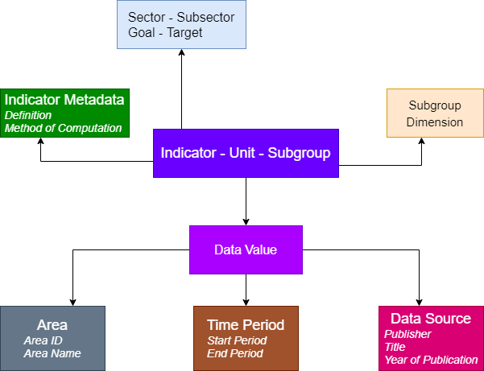Below is the data structure diagram of the underlying database:

### Geographical Coverage Entities

The system will be developed to store and manage data at various geographical levels or administrative boundaries. The geographical level will be termed as Area in this system. Data Manager module will have features to manage Area and their geo-spatial maps. These features are explained in detail in the following chapter. The system will be capable to manage the area at the following levels:

* National
* State
* District

As explained in the data structure section the data values for each Indicator combination will be entered against each of the above-defined area levels. Example: The system will have provisions to enter Infant Mortality Rate at national, state, and district levels for various time periods and data sources. This will help in data analysis and comparison at all geographical levels of various performance indicators.

Below is the system chart of the system:

### System Chart

## System Security

This system will be developed to ensure that all vulnerabilities of the web application will be identified and corrective measures are taken. The web application environment including the scripting language, web server software, and the operating system are mentioned in this document. Configuration and coding will be done in the applications to manage the identified vulnerabilities. A manual testing will be conducted on the applications to ensure that no known vulnerabilities exist in the system. Below are some of the known vulnerabilities that will be handled in the applications:

* Displaying the passwords between client and server in clear text
* Session hijacking
* Cross-site request forgery (CSRF) attack to load a page containing malicious request
* Upload malicious (.exe) file
* Brute force attack
* Not maintaining audit trails
* Runtime/Server error
* View the authenticated page from the cache of the browser
* Server version discloser in header response

## References

Best practices in data management including standardizing and harmonizing of indicators and their related dimensions will be used to develop this system. The system will be designed and developed to meet the objectives of the terms of references of the project. It will cater to the needs of the stakeholders who are looking for a solution that works as an umbrella to cater the needs from collating the data into a centralized database system with features to strengthen data dissemination and effective data presentation.

# Chapter II: Overall Description

## System Perspective

India will play a leading role in determining the success of the SDGs. The SDGs and targets will stimulate action in the overall sustainable human development. India’s national development goals and its “sab ka saath, sab ka vikas” or “development with all, and for all,” policy initiatives for inclusive development converge well with the SDGs.

The Ministry of Statistics and Programme Implementation (**MoSPI**) has been entrusted with the responsibility of developing the National Indicator Framework (**NIF**) which will help in monitoring the progress of the SDGs and associated targets. Statistical indicators of NIF will be the backbone of monitoring of SDGs at the national and state level and will scientifically measure the outcomes of the policies to achieve the targets under different SDGs. NIF has recently been finalized and needs to be monitored and in this context and to support its SDGs work in India, United Nations in consultation with MoSPI has initiated the process of developing SDG India Dashboard. This dashboard will be a solution to streamline the decision process related to SDGs in India. The dashboard allows the user to navigate through all axes crucial for monitoring the progress. The dashboard is intended to bring India’s decision-making process - collecting primary data, accessing external data, cleaning and transforming data and visualizing data- to one place.

The SDG India dashboard brings together data from various sectoral datasets and portals to one common place that will enable India to track its progress towards achieving the SDGs. The dashboard will enable faster and will make more efficient decisions at all levels of governance. MOSPI will have complete ownership of the dashboard and will not only host it on a secure server but also ensure regular data updates and dashboard maintenance in the future. The development of the dashboard will be guided by the following key action points as directed by MOSPI:

* The dashboard will help to track, monitor and report on the SDGs progress in India.
* To ensure the SDG indicators are standardized and harmonized across the national and sub-national level
* To improve coordination and convergence among all stakeholders responsible to report on SDGs progress.
* To strengthen the SDG monitoring in accordance with the data needs at all administrative levels across all stakeholders.
* Using visual widgets to present SDG indicators data and metadata
* To have a data input tool that allows central ministries and State and UTs to enter data against SDG National Indicator Framework (NIF).
* To allow data entry and vetting primarily at the central ministry level by multiple users.
* To encourage open access and use of data across multiple organizations, platforms, and systems international standards make the database comply with Statistical Data and Metadata Exchange (SDMX) standards.
* To develop training user manuals to build the internal capacity of the MOSPI staff and other stakeholders.

## System Functions

This web-based system would comprise of the user interface and data manager applications. This section will provide detailed functionalities of these applications:

#### User Interface

* This will be a web application and will be hosted on a web server.
* This application will be accessed through a web browser and requires an internet connection.
* The application will start with the home page that will have the Government of India logo and SDG branding.
* The home page will have a SDG wheel which will be clickable. Each spoke of the wheel will represent a SDG and clicking on the spoke will display the short description of the SDG goal.
* Each SDG goal description will have an explore button that allows to jump directly to that goal visualization page.
* The first page of the dashboard will be the Overview page. This page will allow you to browse through the SDG framework that comprises of the SDG goals and targets.
* There will be a page to visualize the national SDG data called as India page.
* This page will have options to navigate the visualizations by goals, targets, indicators, states, and districts.
* Data for each SDG indicator will be presented in a visualization widget.
* Each visualization widget will present the data in a graph that is set by the administrator. The user will have an option to select a suitable chart type from the list – column, bar, line, pie, area, tree map and table.
* Each visualization widget will have options to show/hide labels, show/hide legends, swap the x and y-axis parameters.
* Each visualization widget will have options to download in printable format, share on social media or view the chart in full screen.
* There will be a metadata page that will allow you to view the metadata associated with the SDG indicators. You will have the option to navigate through the SDG indicators.
* Search option on the dashboard will allow you to search for a SDG indicator and view its data in the visualization widget.

#### Data Manager

* This will be a web application and will be hosted on a web server along with the user interface application.
* This application will be accessed through a web browser and requires an internet connection.
* This application will have user restriction and access to the application will be through a login process.
* Multiple users will be created in the system to allow them to enter data for their assigned SDG indicators.
* The system admin will import the area hierarchy, area maps, SDG indicators with their disaggregation.
* The system admin will be able to import SDG data collated in a CSV format with a standard format of data elements.
* Using this application imported data can be view, edited and published.
* The logs will be generated for the import data process and the system admin will be able to manage the logs.

## User Roles

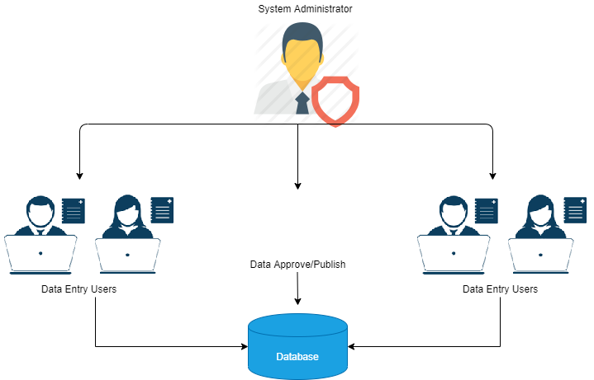To allow controlled data entry in the system multiple users will be created in the system. Each ministry/department will have a user who will have permission to enter/edit data for their own assigned SDG indicators (see figure below).

There will be two type of users in the system:

1. System Administrator
2. Data Entry Users

Below are the rights and permissions assigned to the users of the system.

**System Administrator**

This is the default user with super administration rights that will have access to all the modules of the data manager application. The system administrator will also have the rights to perform data entry, data approve and data publishing.

**Data Entry**

Data will be entered by the users with the Data Entry role. Each data entry user will be assigned specific indicators. They will be able to enter/edit data for the indicators assigned to them.

## Operating Environment

The system will be a web-based online application. It will be developed to run over the internet. The application will be deployed on a web server with the following specifications:

Operating System: Ubuntu v16.04 LTS

Processor: 16 vCPU

Internal Memory: 32 GB (recommended)

Hard Disk Space: 100 GB (recommended)

Internet Bandwidth: 100 mbps 1-1

The system will be developed in the following environment:

Front-end Language: Angular v8.2.11, HTML v5.0, CSS v3.0, Highcharts v7.2.0

Back End Language: Node.js v10.15.3, PHP v7.1.30

Framework: Express.js, Laravel

ORM: Mongoose v4.13.5

Database System: Mongo DB v 4.0.12

Server Type: NPM v 5.6.0

Docker: v18.09.8

Docker-compose version: v1.22.0

Data will be imported from various source available in the CSV format.

## Design and Implementation Constraints

This system will be designed to help in measuring the progress of SDGs indicators. It rekindled an interest in the quality and availability of data for measuring the country’s performance, scheme design and management. Although some progress has been made in strengthening the statistical system, this progress is uneven and India continues to lack uniform statistical systems. All States and UTs use varied data monitoring systems. This system will support the development of reliable, high-quality data on a range of subjects. Data is currently not available for some of the NIF indicators. However, to initiate the monitoring process, MOSPI decided to show all the indicators for which data is available and identify the data gaps of those indicators where data is not available. This will help in better data collection, tracking, monitoring and reporting on SDGs.

## User Documentation

Detailed user manuals will be developed for all the applications. These user manuals will explain the step-by-step method to explain the functionality and usage of the system. The manual for the users will help them understand the steps to use them.

## Assumptions and Dependencies

The system is dependent on data imported and entered from data sources. The NIF indicators should be aligned to the SDG Framework. The frequency of data updates will be based on data sources available and publications, although the system will have features to import data as and when required.

## External Interface Requirements

#### User Interfaces

The user interface for the software shall be compatible to the common used internet browsers including Google Chrome, Mozilla Firefox, Internet Explorer and Apple Safari. The user interface will be easy to navigate through all the screens with minimum training required. The interface will have a page-driven approach where each module will be viewed in their own respective pages.

#### Hardware Interfaces

The system will be deployed on commonly available web servers and cloud-based services. Internet connectivity is required to run the system.

#### Software Interfaces

The system will be developed using open-source technologies that would allow easy extensibility and scalable communication Interfaces. The system will use the HTTP protocol for communication over the internet.

# Chapter III: System Features

This section will cover the detailed functional requirements of the two applications and their modules. The following are the detailed explanation of the features of these applications.

1. The system will comprise of two applications: User Interface and Data Manager.
2. The user interface will comprise of home page, overview page, India page, metadata page, and search option.
3. The user interface will provide the features to view SDG indicators data using visualization widgets in various charts.
4. There will be options to navigate, search and view SDGs dashboard by goal, target, indicator, state, and district. The data will be viewed for various geographical areas and time periods.
5. The overview page will show the complete SDG framework that comprises of goals and targets.
6. The India page will allow you to view the data of all indicators of the selected goal by geographical area in goal view. It will also allow you to view the data by disaggregation view and geographical view. The geography filters will allow the user to drill-down to view the data for any specific state or district (where available).
7. The metadata page will allow the user to view the metadata associated with the SDG indicators.
8. The data manager application will comprise of various modules and sub-modules to manage area, indicator, data, and metadata.
9. The data manager module will seamlessly import data and metadata available in pre-defined CSV format files into the database.

Following are the detailed functional requirements for each of the application of the system:

## User Interface

**Description and Priority**

This application will allow the user to search, visualize, analyze, download and share the data of the sustainable development indicators by geographical area, time period and data source. The application will have a dashboard view and will be area driven to show the performance of the sustainable development indicators over a period of time. The application will identify the bottlenecks and the required corrective actions just by having a look over the dashboard.

**Functional Requirements**

This application will comprise of the various dashboard views. This application will have three functional sections besides having a section for Metadata. These sections are explained below in detail, along with their features.

1. Home page
2. Overview
3. India
4. Metadata
5. Search

### 1.1 Home page

**Description and Priority**

This will be the first page of the user interface application. When the user will use the web browser to open the application the landing page will show the branding, logos, SDG wheel, etc.

**Functional Requirements**

REQ-1: The user interface application will be opened in a web browser.

REQ-2: The landing page will show the partner’s logos and the SDG wheel.

REQ-3: The SDG wheel when clicked will show the details of each Goal when selected.

### 1.2 Overview

**Description and Priority**

It will show the SDG wheel. The module will have the option to select a specific SDG Goal and view its targets.

**Functional Requirements**

REQ-1: The overview page will show the colored SDG wheel with all the 17 SDGs in the left side of the page and the selected goal’s target on the right side.

REQ-2: The user will be allowed to click on each SDG to view the targets of the selected Goal.

REQ-3: The website’s banner image will be there on the left side of the top band to navigate back to the home page from other pages.

REQ-4: The Main menu will there to the right side of the banner help to navigate to the various modules of the website like Overview, India, Metadata and Search.

REQ-5: There will be a search option on the top right corner of the page to search/explore the indicators.

### 1.3 India

**Description and Priority**

This will be the main module of the application.

**Functional Requirements**

REQ-1: The website’s banner image will be there on the left side of the top band to navigate back to the home page from other pages.

REQ-2: There will be two sections available on this page: the navigation section and the visualizations section.

REQ-3: The navigation section will have five drop-down lists –Goal, Target, Indicator, State, and District.

REQ-4: The visualization section will show the selected SDG indicators data in visualization widgets.

This section will act as the main dashboard containing widgets of various indicators by goals and targets. User will be able to visualize the data in three views which are as follows:

1. Goal view
2. Target view
3. Indicator view
4. State view
5. District view

Users will be able to see the dashboard by selecting a state and district from the drop-down list which will appear under the goal, target and indicator drop-down list.

REQ-1: The widget will present the data for the Indicator-Unit combination for India.

REQ-2: Each Indicator data will be presented in an appropriate chart type.

REQ-3: There will be an option to change chart type, switch on/off data values, full screen view, download the chart and share it on social media.

REQ-4: Each visualization will be downloadable an image into JPEG format.

REQ-5: There will be an option to view the metadata of each indicator.

REQ-6: Search option will be present on the page to allow to search of the indicator.

REQ-7: There will be an option to select a state and district.

REQ-8: If no data is available for the SDG indicator at any level, disaggregation or time period that a message “Data not available” will show.

#### 1.3.1 Goal view

**Functional Requirements**

REQ-1: The navigation section will have the Goal drop-down, there will an option to select a goal from the drop-down list.

REQ-2: The visualization section starts with a header that shows the goal name along with the number of targets and indicators of the selected goal.

REQ-3: You will also find a Show/Hide option in the corner of the header.

REQ-4: The visualization section will show all the indicators of the selected goal grouped by its targets in the visualization widgets.

REQ-5: There will be an option to view the metadata of the indicators by clicking on the “i” (information) button.

REQ-6: By default, the first goal will be selected and its targets and indicators will be seen in the visualization section.

REQ-7: Each visualization widget will show the indicator name and its unit of measurement.

REQ-8: The widget will present the data in the most suitable chart type.

REQ-9: The chart menu will allow changing the bar chart to various charts. You will change the bar chart view to – Line Chart, Bar chart, Column chart, Pie chart, Area chart, and Tree map.

REQ-10: There will be some other widget toolbar options available to view data in the table, switch on/off data values and legends over the chart, swap x, and y-axis parameters and to view the chart in the full-screen mode.

REQ-11: Each chart will have the option to download in jpeg format.

REQ-12: Each chart will also have the option to share it on Facebook and Twitter.

REQ-13: The data source name will be shown below the chart in the widget.

REQ-14: This view will appear when the user will select a goal from the goal drop down list.

REQ-15: This view will show visualization widgets for each indicator by all targets of the selected goal.

REQ-16: This view will show data for India by default else it will show the data of the state if selected.

REQ-17: Data will be shown by default for the subgroup "Total” and if data for default subgroup is not available then show disaggregated data.

REQ-18: Data will be shown for all the time periods.

REQ-19: By default, the data will be shown in the bar chart.

#### 1.3.2 Target view

**Functional Requirements**

REQ-1: The navigation section will have the target drop-down, there will an option to select a target from the drop-down list.

REQ-2: The visualization section will show all the indicators of the selected goal grouped by its targets.

REQ-3: The visualization section starts with a header that shows the goal name along with the number of targets and indicators of the selected goal.

REQ-4: You will also find a Show/Hide option in the corner of the header.

REQ-5: This view will appear when the user will select a target from the target drop down list.

REQ-6: This view will show visualization widgets for each indicator of the selected goal and target.

REQ-7: This view will show data for India by default else it will show the data of the state if selected.

REQ-8: Disaggregated data will be shown by default and if disaggregated data is not available then show default subgroup.

REQ-9: Data will be shown for all the time periods.

#### 1.3.3 Indicator view

**Functional Requirements**

REQ-1: The navigation section will have the indicator drop-down, there will an option to select an indicator from the drop-down list.

REQ-2: The visualization section starts with a header that shows the indicator name.

REQ-3: You will also find a Show/Hide option in the corner of the header.

REQ-4: You will be able to see a color theme geospatial map of the state-level that depicts the selected indicator data.

REQ-5: The data ranges will be calculated by calculating the number of data values along with the minimum and maximum data values.

REQ-6: Each data range will be represented by a default color.

REQ-7: To the right side of the map, you will see the drop-down lists to select disaggregation and time period when data will be available for multiple disaggregation and time periods.

REQ-8: Below the disaggregation and time period drop-down, the map data will be presented in a bar chart.

REQ-9: The data source name will be shown below the color theme geospatial map of the state-level.

REQ-10: This view will appear when the user will select an indicator from the indicator drop-down list.

REQ-11: This view will show the state color theme map for the selected indicator of the selected goal and target.

REQ-12: This view will show data for all states and if data for states is not available then show India data in visualization widget.

REQ-13: Data will be shown for the default subgroup along with an option to change disaggregation if disaggregated data is available.

REQ-14: Most recent data will be shown along with the option to change time period if data is available for multiple time periods.

REQ-15: If the data for states will not be available then a bar chart will show with data for India.

#### 1.3.4 State view

**Functional Requirements**

REQ-1: State will be selected from the state drop-down list that will show all the states and UTs of India.

REQ-2: This view will show the state color theme map for the selected indicator of the selected goal and target.

REQ-3: This view will show data for the selected state and if data for state is not available then the “No data available” message will show.

REQ-4: Data will be shown for the default subgroup along with the option to change disaggregation if disaggregated data is available.

REQ-5: Most recent data will be shown along with the option to change time period if data is available for multiple time periods.

REQ-2: The district list drop down will get populated of the selected state.

#### 1.3.5 District view

**Functional Requirements**

REQ-1: District will be selected from the state drop-down list that will show all the districts of the selected state/UT.

REQ-2: This view will show the district color theme map for the selected indicator of the selected goal, target, indicator and state.

REQ-3: This view will show data for the selected district and if data for the district is not available then the “No data available” message will show.

REQ-4: Data will be shown for the default subgroup along with the option to change disaggregation if disaggregated data is available.

REQ-5: Most recent data will be shown along with an option to change time period if data is available for multiple time periods.

#### Metadata

**Description and Priority**

This page will allow the user to view metadata of the SDG Indicators.

**Functional Requirements**

REQ-1: The website’s banner image will be there on the left side of the top band to navigate back to the home page from other pages.

REQ-2: The metadata page will have two sections – The search section to search from the SDG framework – Goals & its Targets and Indicators and the metadata details section that will show the metadata details of the selected indicator.

REQ-3: The metadata details will include the following information: indicator name, goal name, target name, computation description of indicator, data source ministry/org, data reference period, periodicity of the indicator, unit of measurement, latest data availability and data dissemination.

REQ-4: List of all the goals and targets will be available in the left pane.

REQ-5: By default, prefilled metadata information of the first indicator of SDG1 and target1 will show in the right pane.

REQ-6: If the metadata of the selected indicator is not available, ‘No metadata available’ message will show.

#### Search

**Description and Priority**

The search option will allow a free-text search to search the SDG indicators and view its associated visualization widgets.

**Functional Requirements**

REQ-1: The website’s banner image will be there on the left side of the top band to navigate back to the home page from other pages.

REQ-2: The search page will allow exploring the indicators of a selected goal and target.

REQ-3: The drop-down list will be available to select the required goal and indicator.

REQ-4: You will able to view the visualization widgets of all the indicator-unit combinations of the selected goal and indicator.

REQ-5: Each visualization widget will show the indicator name and its unit of measurement.

REQ-6: The widget will present the data in the most suitable chart type.

REQ-7: The chart menu will allow changing the bar chart to various charts. You will change the bar chart view to – Line Chart, Bar chart, Column chart, Pie chart, Area chart, and Tree map.

REQ-8: There will be some other widget toolbar options available to view data in the table, switch on/off data values and legends over the chart, swap x, and y-axis parameters and to view the chart in the full-screen mode.

REQ-9: Each chart will have the option to download in jpeg format.

REQ-10: Each chart will also have the option to share it on Facebook and Twitter.

REQ-11: The data source name will be shown below the chart in the widget.

## Data Manager

The system needs a backend database to successfully implement the requirements mentioned for the frontend dashboard. This application will serve as the backend application and will provide the functionality to manage the underlying database. It will have the following modules:

1. Login
2. Data Summary
3. Data Template
   1. Import Area
   2. Import Indicator
   3. Import Chart Template
   4. Import Data
   5. Import Metadata
4. Data Entry / Edit
5. Data Approve / Publish
6. Log
7. SDMX

The following section lists the detailed requirement specifications of each module.

### 2.1 Login

#### 2.1.1. Description and Priority

Login module provides a login facility to the system. Users will log in to the system using the assigned email ID along with the password for the authentication. Users will have provision to request a new password in case the user forgets the password.

#### 2.1.2 Functional Requirements

The following will be the functional requirements of this module:

REQ-1: Authorized users will be able to login to the system by using their email ID and password.

REQ-2: In case of invalid login details, appropriate messages will be displayed.

REQ-3: The logout option will be provided after successfully logging into the system.

### 2.2 Data Summary

#### 2.2.1 Description and Priority

This module will be the landing page of the data manager application. It will provide the database summary information by reporting the counts of the key dimensions of the underlying database.

#### 2.2.2 Functional Requirements

The following will be the functional requirements of this module:

REQ-1: This will be the landing page of the data manager application.

REQ-2: The database summary page will display the count of eight major database dimensions – the Indicator, IUS combination, Metadata, Default chart type, Area, Source, Data Values, and Users.

REQ-3: Each count will also show the last updated date under each database dimension count.

### 2.3 Data Template

#### 2.3.1 Import Area

**Description and Priority**

The administrator of the system will have access to this module. This module will allow you to manage the master list of the geographical areas and their maps. This module will have the following options to:

* Download Area Empty Template
* Download Area Template with Data (when data is available)
* Upload Area Filled Template
* Import Area into the Database

This Area template format is available in this document in **Annexure** **H: Data Templates**. The administrator after entering the data into the template can import the area into the database.

**Functional Requirements**

The following will be the functional requirements of this module:

REQ-1: The administrator will be able to download an area empty template in CSV (Comma Separated Value) formatted file.

REQ-2: The template will have the following columns: Area ID, Area Name, Area Level, Area ParentID, Area Group.

REQ-3: The format of the Area ID will be the standard format that is used generally in census datasets. This format assigns multiples of three Alpha-numeric characters based on the area level. For example

* IND is the Area ID for India which is referred to as Level 1.
* IND001 is the Area ID for Jammu & Kashmir which is referred to as Level 2.
* IND001001 is the Area ID for Sri Nagar which is referred to as Level 3.

REQ-4: The following validation is checked on the Area ID and Area Name

* They should not be blank
* They should not be duplicate
* They should not contain any special character

REQ-5: The geoJSON file containing the GIS data along with Area ID will be imported at the back end in the database.

REQ-6: The Area Level denotes the geographical level. For example, Level 1 is generally national level and Level 2 onwards are assigned to sub-nationals.

REQ-7: Area Parent ID refers to the Area ID of the parent. For example, the parent ID of India will be the Area ID of Asia.

REQ-8: The Area Group column will contain the Area IDs of all the areas that fall in a group. For example, India falls in Asia and in South Asia.

REQ-9: The Area Parent ID and Area Group are optional columns and will be used based on the requirements of the project.

REQ-10: The administrator will be able to download an area template with data in CSV or XML format (SDMX complaint).

#### 2.3.2 Import Indicator

**Description and Priority**

This module will help to create the indicator structure including indicators (I), their unit(U) of measurement and their disaggregation subgroups(S). The IUS combinations and the related dimensions are imported using this module. This Indicator template format is available in this document in **Annexure** **H: Data Templates**. The administrator after entering the data into the template can import indicators into the database.

**Functional Requirements**

REQ-1: This module will have an option to download an empty IUS template in CSV format.  
REQ-2: There will be an option to download the complete IUS list available in the database in CSV format (once the indicators will be imported in the database).

REQ-4: After the indicator details as per the format requirement are entered in the template the user will browse and upload the template to be imported in the database.

REQ-5: Once the template is uploaded there will be an option to import it into the database.

REQ-6: The administrator will be able to download indicator template with data in CSV or XML format (SDMX complaint)

#### 2.3.3 Import Default Chart Type

**Description and Priority**

This module will help to set default chart type and time periods that represent the graph in the user interface. This chart template format is available in this document in **Annexure** **H: Data Templates**. The administrator after entering the data into the template can import indicators into the database.

**Functional Requirements**

REQ-1: This module will have the option to download an empty template in CSV format.

REQ-2: There will be an option to download the complete chart settings available in the database in CSV format (once the chart template will be imported in the database).

REQ-3: After the chart settings as per the format requirement are entered in the template the user will browse and upload the template to be imported in the database.

REQ-4: Once the template is uploaded there will be an option to import it into the database.

#### 2.3.4 Import Data

**Description and Priority**

This module will help you to import the data against the indicator structure that will be imported in the previous modules. This data template format is available in this document in **Annexure** **H: Data Templates**. The administrator after entering the data into the template can import the data into the database. The Data Entry template will have the following columns:

* AreaID
* AreaName
* TimePeriod
* Source
* Sector
* Subsector
* Goal
* Target
* Indicator
* Unit
* Subgroup
* DataValue
* Footnote

Based on the role this module will control the importing of the data. During the import process, the data will be checked for duplicates and invalid entries. A log will be generated to report on the import process.

**Functional Requirements**

REQ-1: User with database administrator role will be able to upload the data.

REQ-2: This module will have the option to download an empty data template in CSV format.

REQ-3: There will be an option to download the complete data available in the database in CSV format (once the data will be imported in the database).

REQ-4: The administrator will be able to download a data template with data in XML format (SDMX complaint).

REQ-5: After the data, as per the format requirement are entered in the template the user will browse and upload the template to be imported in the database.

REQ-6: The data template will be checked for duplicate and invalid entries while the import process. Below are the checks

* Rows will not be imported if the following cells are left blank:
  + - AreaID
    - TimePeriod
    - Source
    - Indicator
    - Unit
    - Subgroup
    - DataValue
* AreaID should exist in the database.
* In case a duplicate row will be found it will overwrite the old data value with the new data value when all the cells except data value will match.
* Time period will be only imported if entered in one of the following formats:
  + - YYYY
    - YYYY.MM
    - YYYY.MM.DD
    - YYYY-YYYY
    - YYYY.MM-YYYY.MM
    - YYYY.MM.DD-YYYY.MM.DD

REQ-7: A import log will be generated to report the summary of the import process including the import status as successful or failed. The log will report on the following details:

* Log file name
* Data Template file name (CSV format)
* Total Rows available in the template and Total Rows imported
* List of invalid rows not imported. This list will show the reason of not imported – duplicate, blank cell, invalid format.

REQ-7: *Data successfully imported in this module will be marked as unapproved and will not be shown in the user interface unless the system administrator will approve and publish this data.*

#### 2.3.5 Import Metadata

**Description and Priority**

This module will import the metadata against the Indicator(I) and Unit(U) combination. Each unique IU will have metadata associated with it. This metadata template format is available in this document in **Annexure** **H: Data Templates**. The administrator after entering the metadata into the template can import the template into the database.

**Functional Requirements**

REQ-1: This module will have an option to download an empty metadata template in CSV format.

REQ-2: There will be an option to download the complete metadata list available in the database in CSV format (once the metadata will be imported in the database).

REQ-3: After the metadata details as per the format requirement are entered in the template the user will browse and upload the template to be imported in the database. Following is the metadata structure:

* Indicator
* Unit
* MT1
* MT2
* MT3
* MT4
* MT5
* MT6
* MT7
* MT8
* MT9

The nine columns name like MT1, MT2 are the metadata tags provided for the user to enter the metadata details. The tables below explain the metadata tags with their headings mapped in the underlying database. All metadata tags are optional and can be left blank when not applicable.

|  |  |
| --- | --- |
| MT1 | Definition |
| MT2 | Method of Computation |
| MT3 | Comments and Limitations |
| MT4 | Sources of Discrepancies between Global and National Figures |
| MT5 | Process of Obtaining Data |
| MT6 | Treatment of missing values |
| MT7 | Data Availability |
| MT8 | Regional and Global Estimates |
| MT9 | Expected Time of Release |

REQ-4: Once the template is uploaded there will be an option to import it into the database.

### 2.4 Data Entry / Edit

**Description and Priority**

This module will allow data entry and edit options. Data Value and its related Time Period and Source will be available for editing. The user will be able to delete the existing record and add a new data against an existing IUS combination. Data will be entered by generating a data entry grid. The user will generate this grid by selecting the required IUS combination, Area, Time Period and Source. While generating the data entry grid there will be an option to add a new time period and source.

**Functional Requirements**

REQ-1: System administrators will be able to access this module.

REQ-2: There will be an option to set the data grid by setting to view rows per page.

REQ-3: The user will have an option to sort the data grid by columns and search the required indicator.

REQ-4: There will be an option to delete the existing record.

REQ-5: The user will be able to edit the Time Period, Source and Data Value of an existing record.

REQ-6: There will be an option to generate a data entry grid by select the existing IUS combination, Area, Time Period and Source.

REQ-7: All data entered or edited in this module will be pending for approval and publishing before it appears in the user interface application.

### 2.5 Data Approve / Publish

**Description and Priority**

This module will allow you to validate and publish the data imported, entered or edited by the administrator. This module will be important to implement the validation process where data will not be available for viewing in the user interface before it is approved by the data approver user and published by the system administrator.

**Functional Requirements**

REQ-1: The System administrator will be able to approve and publish data.

REQ-2: There will be an option to set the data grid by setting to view rows per page.

REQ-3: There will have an option to sort the data grid by columns and search the required indicator.

REQ-4: There will be an option to change the status of each data value that is entered, updated or imported to approve and publish.

REQ-5: There will be an option to set the status of one data record or a batch of selected data records.

### 2.6 Log

**Description and Priority**

This module will allow the users to view the import logs which were generated in the Import Data module.

**Functional Requirements**

REQ-1: The system administrator will have access to this module.

REQ-2: All logs generated by the Import Data module will be seen in the data grid.

REQ-3: Detailed information of the log will be seen in this module.

REQ-4: There will be an option to delete and download the logs.

### 2.7 SDMX

**Description and Priority**

This module will allow the users to export and import data elements, Data Structure Definition (DSD) and Code lists in SDMX complaint XML format.

#### 2.7.1 Export SDMX

**Functional Requirements**

REQ-1: All users of data manage will have access to this module.

REQ-2: The user will be able to manage multiple sender and receiver details.

REQ-3: There will be an option to add, delete, edit sender and receiver details like name, position, organization, email id, phone number.

REQ-4: The user will be able to select the Data Structure Definition that will include all the data elements along with their GIDs (unique global identification numbers) to export in XML formatted file (SDMX compliant).

REQ-5: The user will be able to select all data or select data to export in XML formatted file (SDMX complaint).

REQ-6: The user will be able to select code lists including indicator, unit, subgroup, subgroup dimension, sector, subsector, time period, area, source to export in XML formatted file (SDMX complaint).

#### 2.7.2 Import SDMX

**Functional Requirements**

REQ-1: All users of data manage will have access to this module.

REQ-2: The user will be able to upload the Data Structure Definition (all the data elements along with their GIDs), the XML formatted file (SDMX complaint) and import into the database.

REQ-3: The user will be able to upload the data in the XML formatted file (SDMX complaint) and import it into the database.

REQ-4: The user will be able to upload the code lists including indicator, unit, subgroup, subgroup dimension, sector, subsector, time period, area, source available in XML formatted file (SDMX complaint) and import into the database.

REQ-5: The user will be able to remove the uploaded file and upload it again.

## Other Nonfunctional Requirements

### Performance Requirements

The system will be interactive and allow data entry and updates when the data will be made available. So in every action-response of the system, there will be no immediate delays. In case of opening the applications and modules, displaying of error and confirmation messages there will be delay much below 5 seconds. In case retrieving data from the database there will be a short span delay based on the number of records to be retrieved in one go. Loader will be implemented to make the user aware of any delays in the processes.

### Safety Requirements

Information transmission will be securely transmitted to the server without any changes in information.

### Security Requirements

The main security concern is for users account where all users will be created and managed by system administrator. Pre-defined users will be created wherever required to avoid hacking. Also, the backup policy shall be adopted by the system administrator outside the system to schedule the backup to mitigate any kind of data loss.

### Software Quality Attributes

If the internet service gets disrupted while sending information to the server, the last saved changes to the database will be available which can be updated by the user, to avoid any discrepancies. The system will be easy to handle and navigate in the most expected way with no delays. In that case, the system program reacts accordingly and transverses quickly between its states.

### Business Rules

The following rules are implied in the system:

* The dashboard will be developed by suggested framework and its indicators.
* Login role will identify the access to the data manager application and its modules.
* Back-end database structure will be created and linked to the user interface application to use the data.
* Best practices of web technologies will be used to design the user screens of both the user interface and the data manager applications.

## Other Requirements

This system will be designed to be adopted by similar operating clients that may have socio-economic indicators based data for tracking, monitoring and reporting development programs and frameworks. The open-source technology used to develop the system will be helpful in customizing, scaling and extending the functionalities to cater to similar requirements.

# Annexure A: Entity-Relation Diagram (ERD)

# Annexure B: State Transition Diagram

## Data Manager

## User Interface

# Annexure C: Data Dictionary

Area

|  |  |  |  |  |  |
| --- | --- | --- | --- | --- | --- |
| Column | Type | Null | Default | Links to | Comments |
| _id | ObjectID | No |  |  |  |
| name | string | No |  | code |  |
| code | string | Yes | NULL |  |  |
| level | number | Yes | NULL |  |  |
| parent | string | Yes | NULL |  |  |
| child | array | Yes | NULL |  |  |
| status | boolean | Yes |  |  |  |

Indexes

| Keyname | Type | Unique | Packed | Column | Cardinality | Collation | Null | Comment |
| --- | --- | --- | --- | --- | --- | --- | --- | --- |
| PRIMARY | BTREE | Yes | No | id | 0 | A | No |  |

Apis

|  |  |  |  |  |  |
| --- | --- | --- | --- | --- | --- |
| Column | Type | Null | Default | Links to | Comments |
| _id | ObjectID | No |  |  |  |
| indicator | string | No |  | code |  |
| unit | string | No |  |  |  |
| subgroup | string | No |  |  |  |
| period | string | No |  |  |  |
| source | string | No |  |  |  |
| value | string | No |  |  |  |
| icon | string | No |  |  |  |

Indexes

| Keyname | Type | Unique | Packed | Column | Cardinality | Collation | Null | Comment |
| --- | --- | --- | --- | --- | --- | --- | --- | --- |
| PRIMARY | BTREE | Yes | No | id | 0 | A | No |  |

Classifications

|  |  |  |  |  |  |
| --- | --- | --- | --- | --- | --- |
| Column | Type | Null | Default | Links to | Comments |
| _id | ObjectID | No |  |  |  |
| name | string | No |  |  |  |
| parent | ObjectID | No |  |  |  |
| type | string | No |  |  |  |

Indexes

| Keyname | Type | Unique | Packed | Column | Cardinality | Collation | Null | Comment |
| --- | --- | --- | --- | --- | --- | --- | --- | --- |
| PRIMARY | BTREE | Yes | No | id | 0 | A | No |  |

Indicators

|  |  |  |  |  |  |
| --- | --- | --- | --- | --- | --- |
| Column | Type | Null | Default | Links to | Comments |
| _id | ObjectID | No |  |  |  |
| name | string | No |  |  |  |
| alies | string | No |  |  |  |

Indexes

| Keyname | Type | Unique | Packed | Column | Cardinality | Collation | Null | Comment |
| --- | --- | --- | --- | --- | --- | --- | --- | --- |
| PRIMARY | BTREE | Yes | No | id | 0 | A | No |  |

ius

|  |  |  |  |  |  |
| --- | --- | --- | --- | --- | --- |
| Column | Type | Null | Default | Links to | Comments |
| _id | ObjectID | No | N |  |  |
| indicator | ObjectID | No |  |  |  |
| unit | ObjectID | No |  |  |  |
| subgroup | ObjectID | No |  |  |  |
| order | number | No |  |  |  |
| high | boolean | No |  |  |  |
| isDefaultSubgroup | boolean | No |  |  |  |
| status | boolean | No |  |  |  |

Indexes

| Keyname | Type | Unique | Packed | Column | Cardinality | Collation | Null | Comment |
| --- | --- | --- | --- | --- | --- | --- | --- | --- |
| PRIMARY | BTREE | Yes | No | id | 0 | A | No |  |

iusClassification

|  |  |  |  |  |  |
| --- | --- | --- | --- | --- | --- |
| Column | Type | Null | Default | Links to | Comments |
| _id | ObjectID | No | N |  |  |
| ius | ObjectID | No |  |  |  |
| classification | ObjectID | No |  |  |  |

Indexes

| Keyname | Type | Unique | Packed | Column | Cardinality | Collation | Null | Comment |
| --- | --- | --- | --- | --- | --- | --- | --- | --- |
| PRIMARY | BTREE | Yes | No | id | 0 | A | No |  |

logs

|  |  |  |  |  |  |
| --- | --- | --- | --- | --- | --- |
| Column | Type | Null | Default | Links to | Comments |
| _id | ObjectID | No | N |  |  |
| importedfile | string | No |  |  |  |
| user | ObjectID | No |  |  |  |
| success_cnt | number | No |  |  |  |
| empty_cnt | number | No |  |  |  |
| duplicate_cnt | number | No |  |  |  |
| notpermitted_cnt | number | No |  |  |  |
| logfile | string | No |  |  |  |

Indexes

| Keyname | Type | Unique | Packed | Column | Cardinality | Collation | Null | Comment |
| --- | --- | --- | --- | --- | --- | --- | --- | --- |
| PRIMARY | BTREE | Yes | No | id | 0 | A | No |  |

metadatas

|  |  |  |  |  |  |
| --- | --- | --- | --- | --- | --- |
| Column | Type | Null | Default | Links to | Comments |
| _id | objectID | No |  |  |  |
| indicator | objectID | Yes | NULL |  |  |
| unit | objectID | No |  |  |  |
| Metas.name | string | No |  |  |  |
| Metas.value | string | No |  |  |  |
| Metas.order | string | No |  |  |  |

Indexes

| Keyname | Type | Unique | Packed | Column | Cardinality | Collation | Null | Comment |
| --- | --- | --- | --- | --- | --- | --- | --- | --- |
| PRIMARY | BTREE | Yes | No | id | 0 | A | No |  |

periods

|  |  |  |  |  |  |
| --- | --- | --- | --- | --- | --- |
| Column | Type | Null | Default | Links to | Comments |
| _id | objectID | No |  |  |  |
| name | string | Yes | NULL |  |  |
| started_on | date | No |  |  |  |
| ended_on | date | No |  |  |  |

Indexes

| Keyname | Type | Unique | Packed | Column | Cardinality | Collation | Null | Comment |
| --- | --- | --- | --- | --- | --- | --- | --- | --- |
| PRIMARY | BTREE | Yes | No | id | 0 | A | No |  |

records

|  |  |  |  |  |  |
| --- | --- | --- | --- | --- | --- |
| Column | Type | Null | Default | Links to | Comments |
| _id | objectID | No |  |  |  |
| area | objectID | Yes | NULL |  |  |
| ius | objectID | No |  |  |  |
| actual.value | number | No |  |  |  |
| actual.period.name | string | No |  |  |  |
| actual.period.start | date | No |  |  |  |
| actual.period.end | date | No |  |  |  |
| actual.verify | string | No |  |  |  |
| actual.user | objectID | No |  |  |  |
| actual.source | string | No |  |  |  |
| actual.footnote | string | No |  |  |  |
| Planned.value | number | No |  |  |  |
| Planned.period.name | string | No |  |  |  |
| Planned.period.start | date | No |  |  |  |
| Planned.period.end | date | No |  |  |  |
| base.value | number | No |  |  |  |
| base.period.name | string | No |  |  |  |
| base.period.start | date | No |  |  |  |
| base.period.end | date | No |  |  |  |
| base.user | objectID | No |  |  |  |
| target.value | number | No |  |  |  |
| target.period.name | string | No |  |  |  |
| target.period.start | date | No |  |  |  |
| target.period.end | date | No |  |  |  |
| target.user | objectID | No |  |  |  |
| frequency | string | No |  |  |  |
| type | string | No |  |  |  |

Indexes

| Keyname | Type | Unique | Packed | Column | Cardinality | Collation | Null | Comment |
| --- | --- | --- | --- | --- | --- | --- | --- | --- |
| PRIMARY | BTREE | Yes | No | id | 0 | A | No |  |

sources

|  |  |  |  |  |  |
| --- | --- | --- | --- | --- | --- |
| Column | Type | Null | Default | Links to | Comments |
| _id | objectID | No |  |  |  |
| name | string | No |  |  |  |
| publisher | objectID | Yes | NULL |  |  |
| year | string | No |  |  |  |
| alias | string | No |  |  |  |

Indexes

| Keyname | Type | Unique | Packed | Column | Cardinality | Collation | Null | Comment |
| --- | --- | --- | --- | --- | --- | --- | --- | --- |
| PRIMARY | BTREE | Yes | No | id | 0 | A | No |  |

subgroups

|  |  |  |  |  |  |
| --- | --- | --- | --- | --- | --- |
| Column | Type | Null | Default | Links to | Comments |
| _id | ObjectID | No |  |  |  |
| name | string | No |  |  |  |
| dimension | string | No |  |  |  |

Indexes

| Keyname | Type | Unique | Packed | Column | Cardinality | Collation | Null | Comment |
| --- | --- | --- | --- | --- | --- | --- | --- | --- |
| PRIMARY | BTREE | Yes | No | id | 0 | A | No |  |

Units

|  |  |  |  |  |  |
| --- | --- | --- | --- | --- | --- |
| Column | Type | Null | Default | Links to | Comments |
| _id | objectID | No |  |  |  |
| name | string | Yes | NULL |  |  |

Indexes

| Keyname | Type | Unique | Packed | Column | Cardinality | Collation | Null | Comment |
| --- | --- | --- | --- | --- | --- | --- | --- | --- |
| PRIMARY | BTREE | Yes | No | id | 0 | A | No |  |

users

|  |  |  |  |  |  |
| --- | --- | --- | --- | --- | --- |
| Column | Type | Null | Default | Links to | Comments |
| _id | objectID | No |  |  |  |
| name | string | No |  |  |  |
| username | string | No |  |  |  |
| email | string | No |  |  |  |
| password | string | No |  |  |  |
| areas | array | No |  |  |  |
| publishers | objectID | No |  |  |  |
| is_admin | boolean | No |  |  |  |
| status | boolean | No |  |  |  |
| type | string | No |  |  |  |

Indexes

| Keyname | Type | Unique | Packed | Column | Cardinality | Collation | Null | Comment |
| --- | --- | --- | --- | --- | --- | --- | --- | --- |
| PRIMARY | BTREE | Yes | No | id | 0 | A | No |  |
| user_id | BTREE | No | No | user_id | 0 | A | No |  |

# Annexure D: Data Flow Diagrams (DFD)

## Level 0

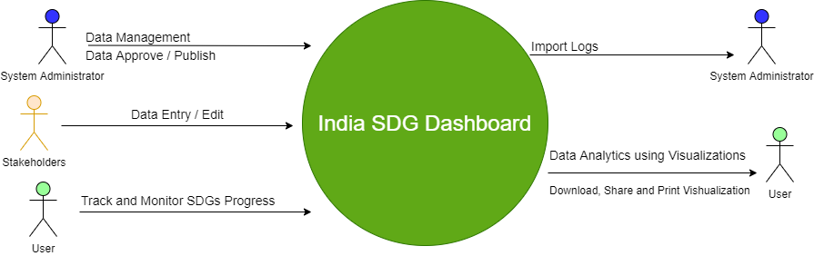

## Level 1

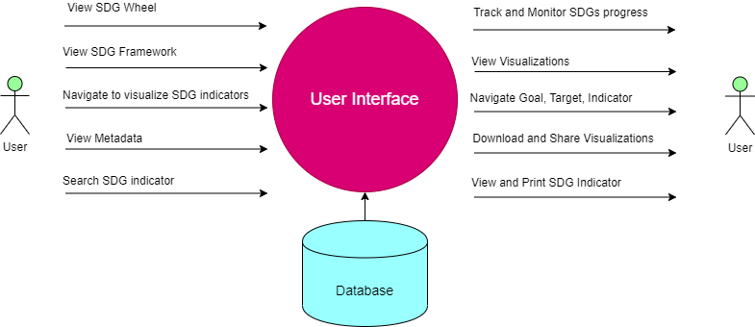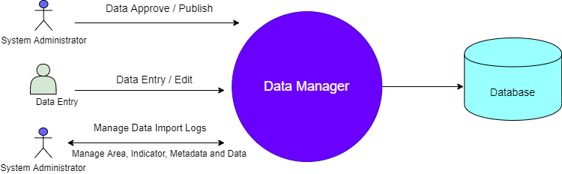

## **Level 2 –** Data Manager

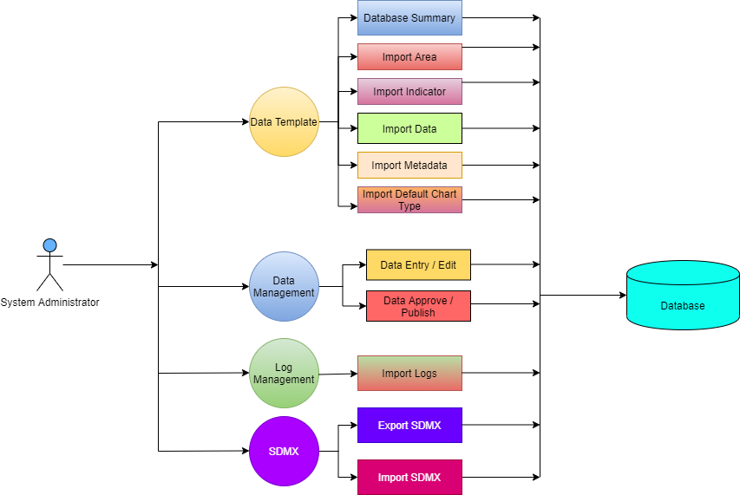

## Level 2 – User Interface

# Annexure E: System Architecture

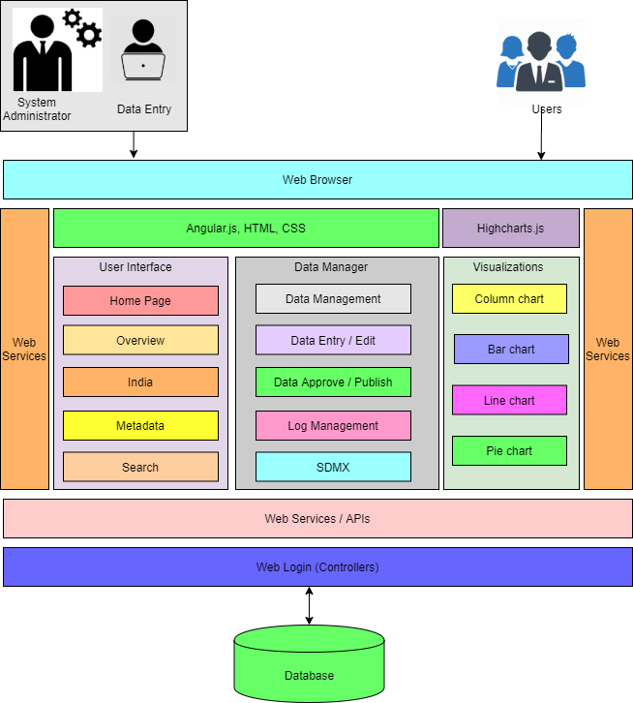

# Annexure F: Software Architecture

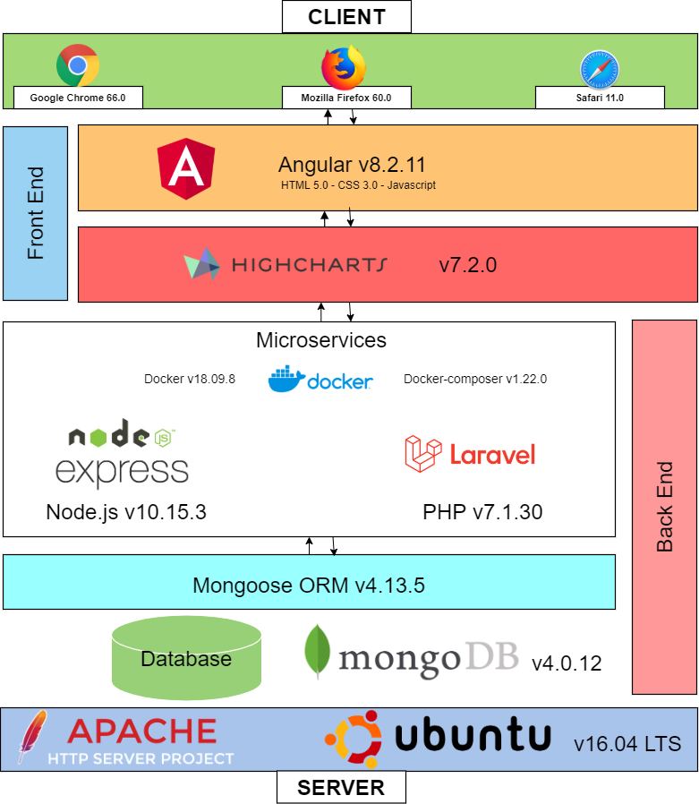

# Annexure G: System Flow Charts

## User Interface

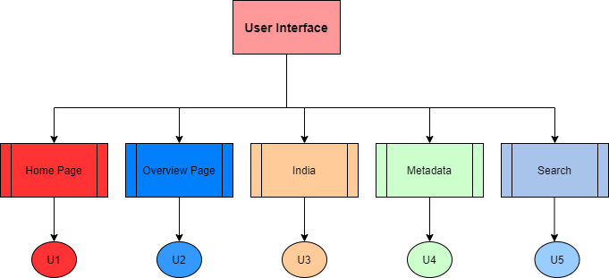

### Data Manager

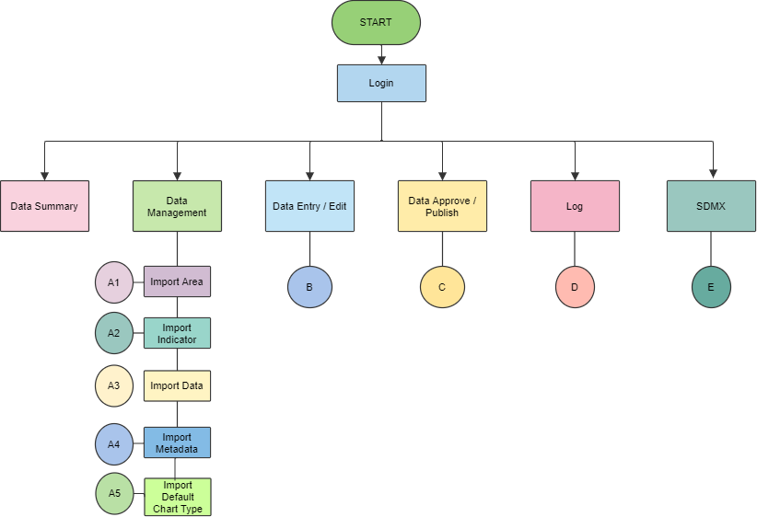

### Data Manager – Import Area

### Data Manager – Import Indicator

### Data Manager – Import Data

### Data Manager – Import Metadata

### Data Manager – Import Default Chart Type

### Data Manager – Data Entry / Edit

### Data Manager – Data Approve / Publish

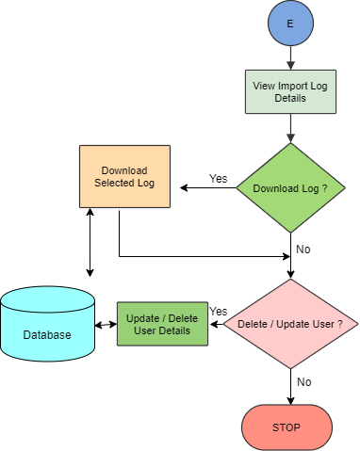Data Manager – Log

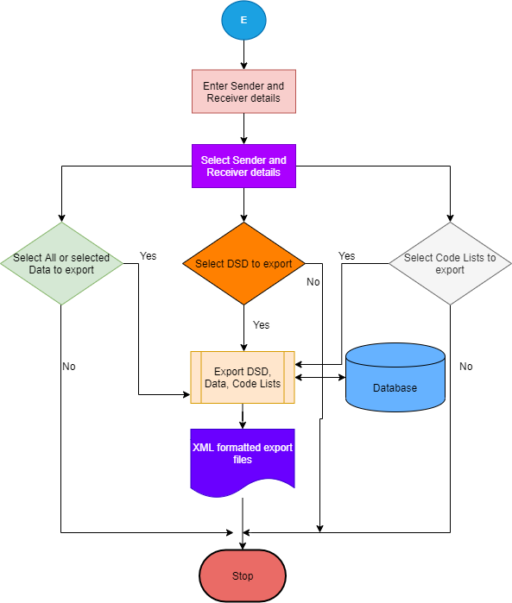Data Manager – Export SDMX

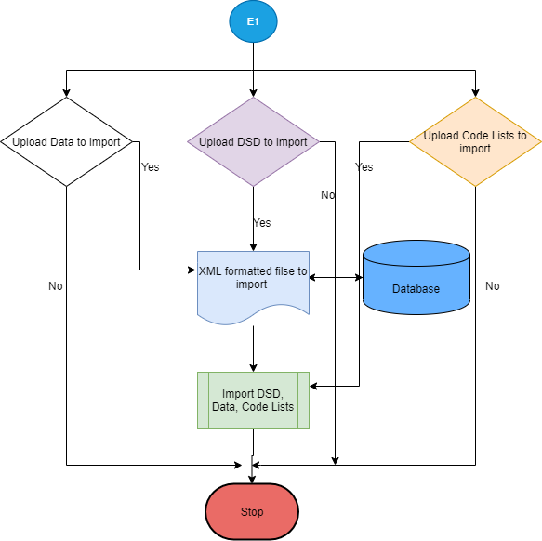Data Manager – Import SDMX

# Annexure H: Data Templates

Area Template

|  |  |  |
| --- | --- | --- |
| AreaID | IND | IND001 |
| AreaName | India | Jammu and Kashmir |
| AreaLevel | 1 | 2 |
| AreaParentID |  | IND |
| AreaGroup |  |  |

Indicator Template

|  |  |  |
| --- | --- | --- |
| Sector | Demography | Demography |
| Subsector | Population | Population |
| Goal | 1. End poverty in all its forms everywhere | 1. End poverty in all its forms everywhere |
| Target | 1.1: By 2030, eradicate extreme poverty for all people everywhere, currently measured as people living on less than $1.25 a day | 1.1: By 2030, eradicate extreme poverty for all people everywhere, currently measured as people living on less than $1.25 a day |
| Indicator | 1.1.2 Poverty gap ratio | 1.1.2 Poverty gap ratio |
| Unit | Percent | Percent |
| SubgroupDimension | Location | Location |
| Subgroup | Rural | Urban |
| SubgroupOrder | 1 | 2 |
| HighIsGood | 0 | 0 |
| IsDefaultSubgroup | 1 | 0 |

Data Template

|  |  |  |
| --- | --- | --- |
| AreaID | IND024 | IND018 |
| AreaName | Gujarat | Assam |
| Timeperiod | 2011-12 | 2011-12 |
| Source | NITI Aayog | NITI Aayog |
| Sector | Demography | Demography |
| Subsector | Population | Population |
| Goal | 1. End poverty in all its forms everywhere | 1. End poverty in all its forms everywhere |
| Target | 1.1: By 2030, eradicate extreme poverty for all people everywhere, currently measured as people living on less than $1.25 a day | 1.1: By 2030, eradicate extreme poverty for all people everywhere, currently measured as people living on less than $1.25 a day |
| Indicator | 1.1.1 Proportion of population living below the national poverty line | 1.1.1 Proportion of population living below the national poverty line |
| Unit | Percent | Percent |
| SubgroupDimension | Location | Location |
| Subgroup | Total | Total |
| SubgroupOrder | 1 | 1 |
| DataValue | 16.63 | 31.98 |
| Footnote |  |  |

Metadata Template

|  |  |
| --- | --- |
| Indicator | 1.1.2 Poverty gap ratio |
| Unit | Percent |
| MT1 | Goal 1: End poverty in all its forms everywhere |
| MT2 | 1.1 By 2030, eradicate extreme poverty for all people everywhere, currently measured as people living on less than $1.25 a day |
| MT3 | It measures shortfall of total population from poverty line based on consumption expenditure approach. A) Numerator: Number of persons below poverty line B) Denominator: Total population |
| MT4 | NITI Aayog |
| MT5 | 2011-12 |
| MT6 | 5 Years |
| MT7 | In percentage |
| MT8 | 2011-12 |
| MT9 | http://mospi.nic.in/sites/default/files/publication_reports/mdg_2july15_1.pdf |

Default Graph Template

|  |  |
| --- | --- |
| Sector | Demography |
| Subsector | Population |
| Goal | 1. End poverty in all its forms everywhere |
| Target | 1.1: By 2030, eradicate extreme poverty for all people everywhere, currently measured as people living on less than $1.25 a day |
| Indicator | 1.1.1 Proportion of population living below the national poverty line |
| Unit | Percent |
| SubgroupDimension | Location |
| Subgroup | Total |
| GraphLevel | 2 |
| TimePeriod | MRT |
| ChartType | bar |

# Annexure I: System Screens

## User Interface

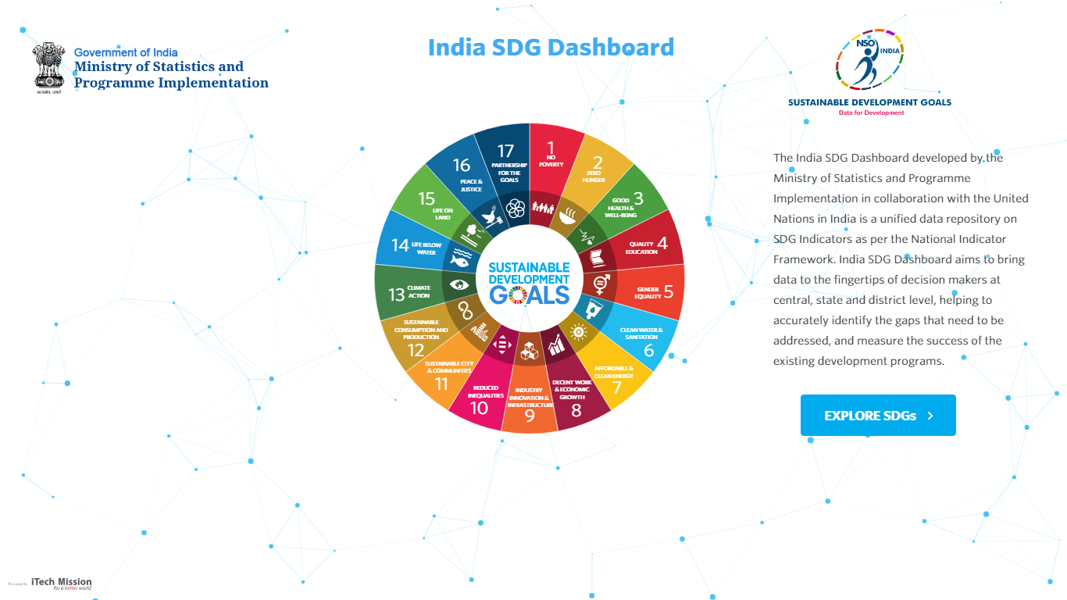

Figure 1.1 – Home Page

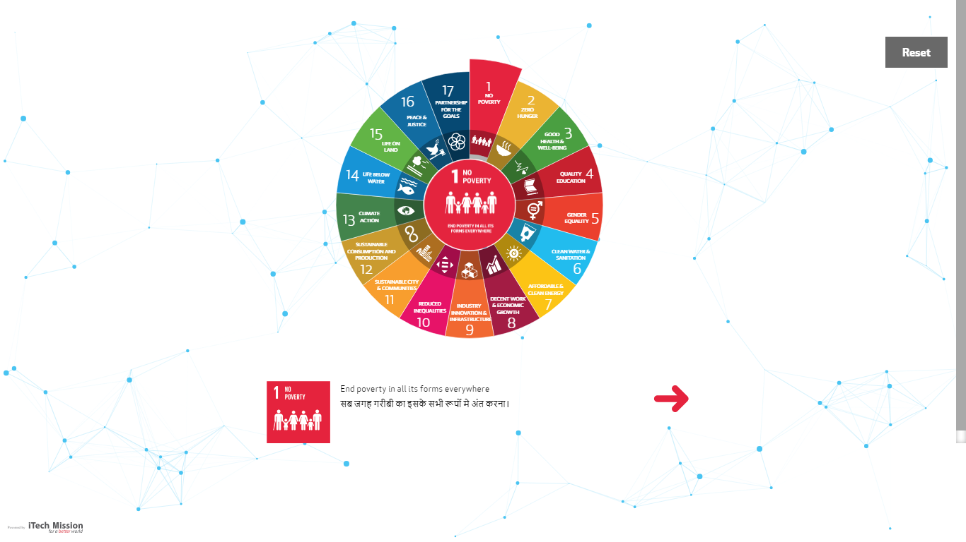

Figure 1.2 – Navigation Page

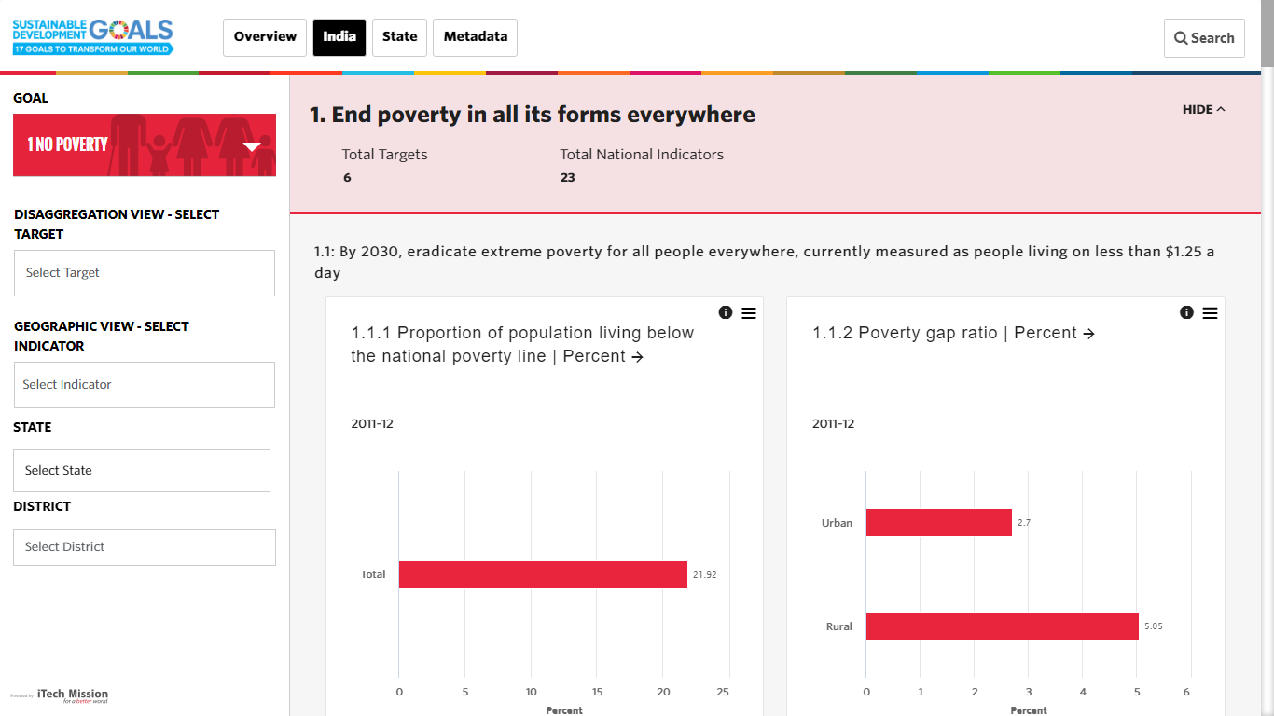Figure 1.3 – Overview Page

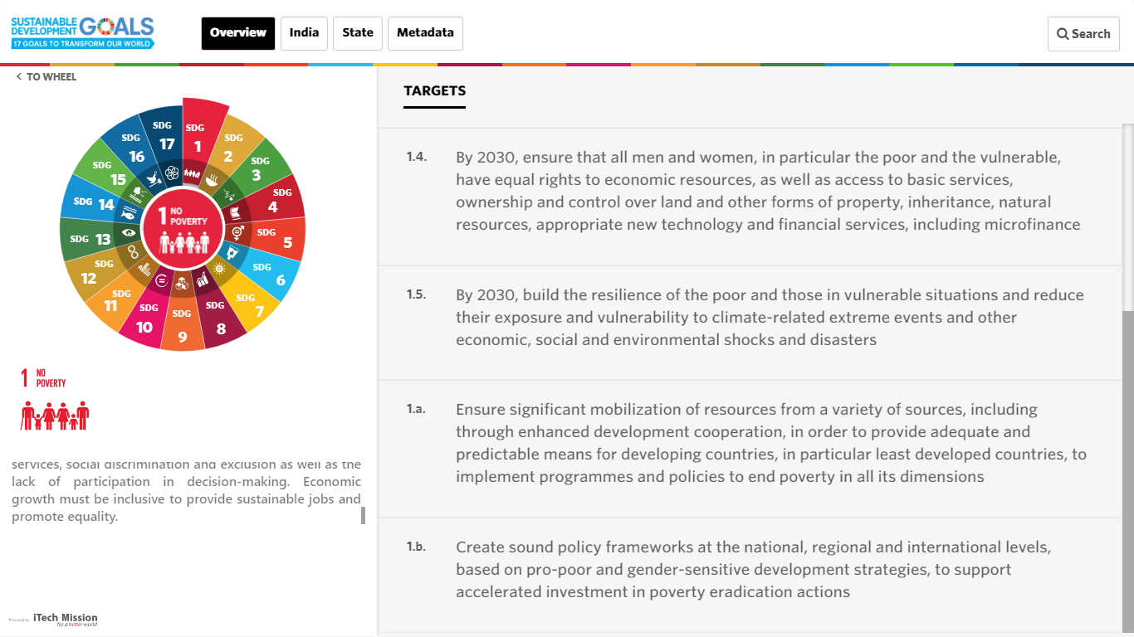

Figure 1.4 – India Goal Page

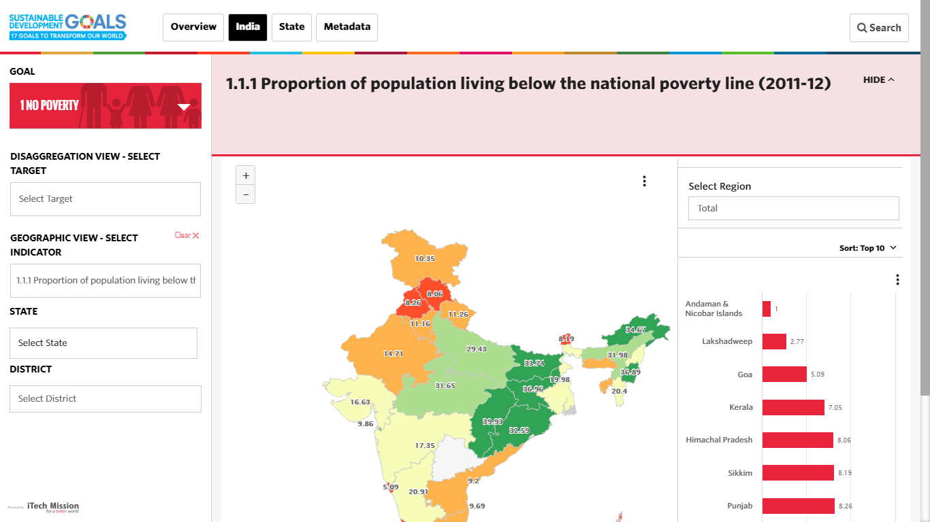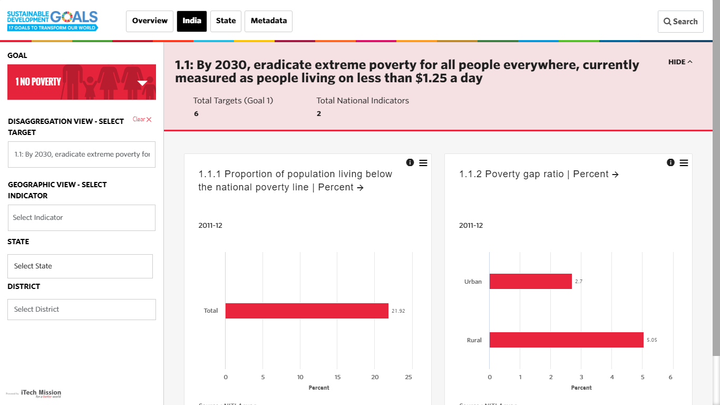Figure 1.5 – India Target Page

Figure 1.6 – India Indicator Page

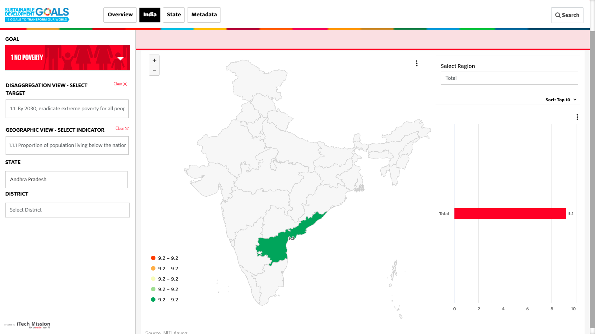Figure 1.7 – India State Page

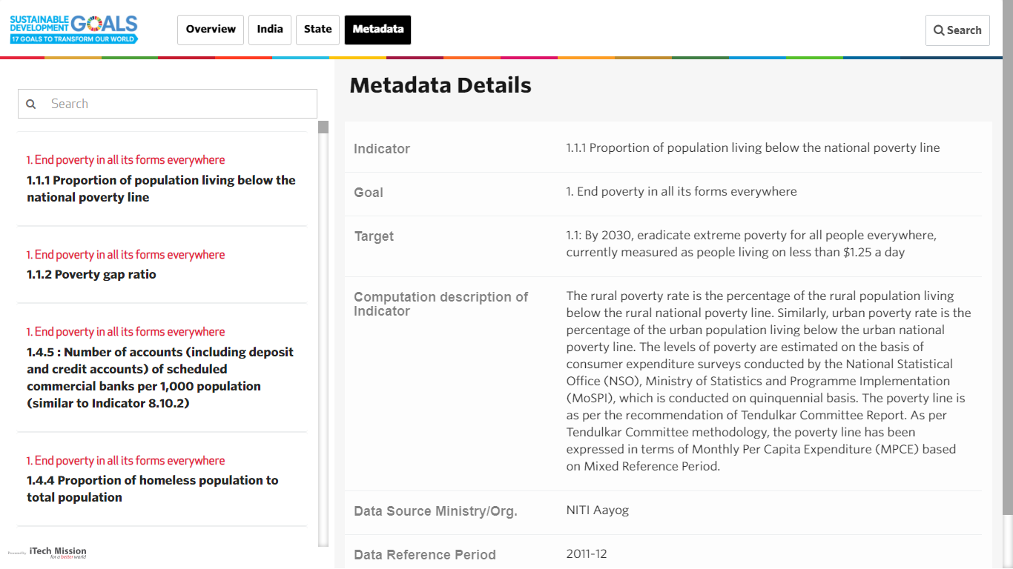

Figure 1.8 – Metadata Page

Figure 1.9 – Search Page

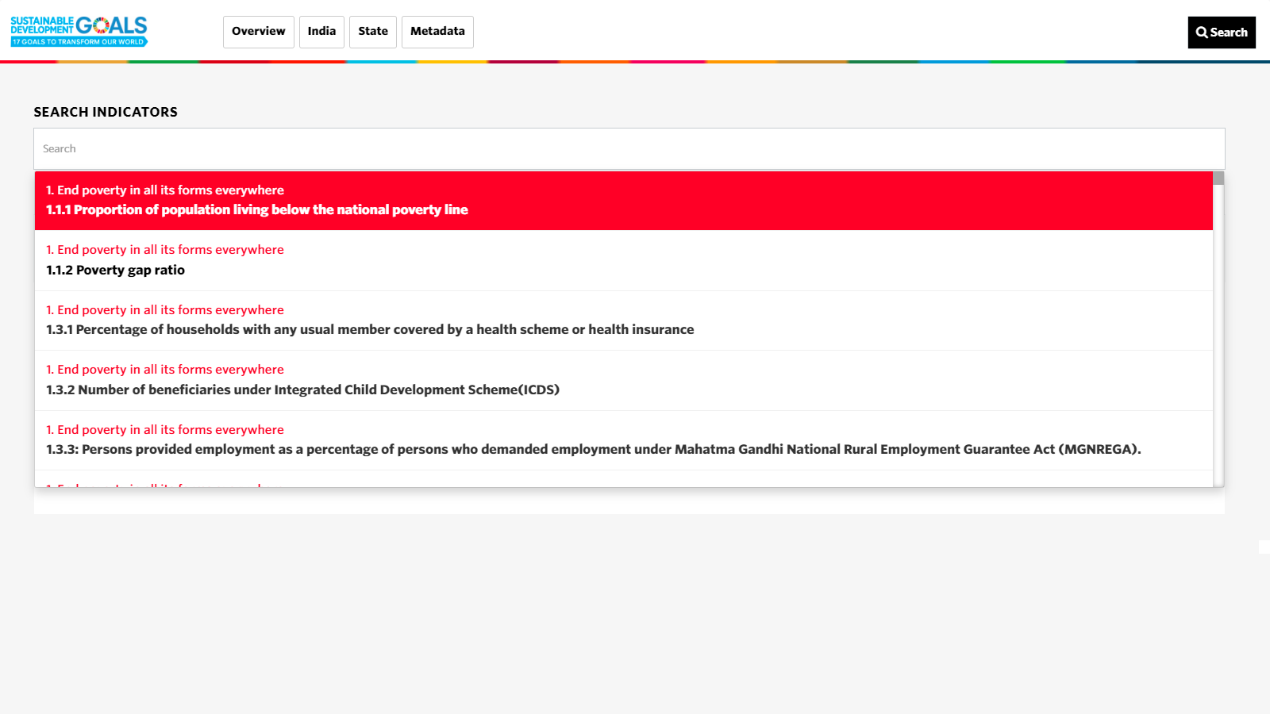

## Data Manager

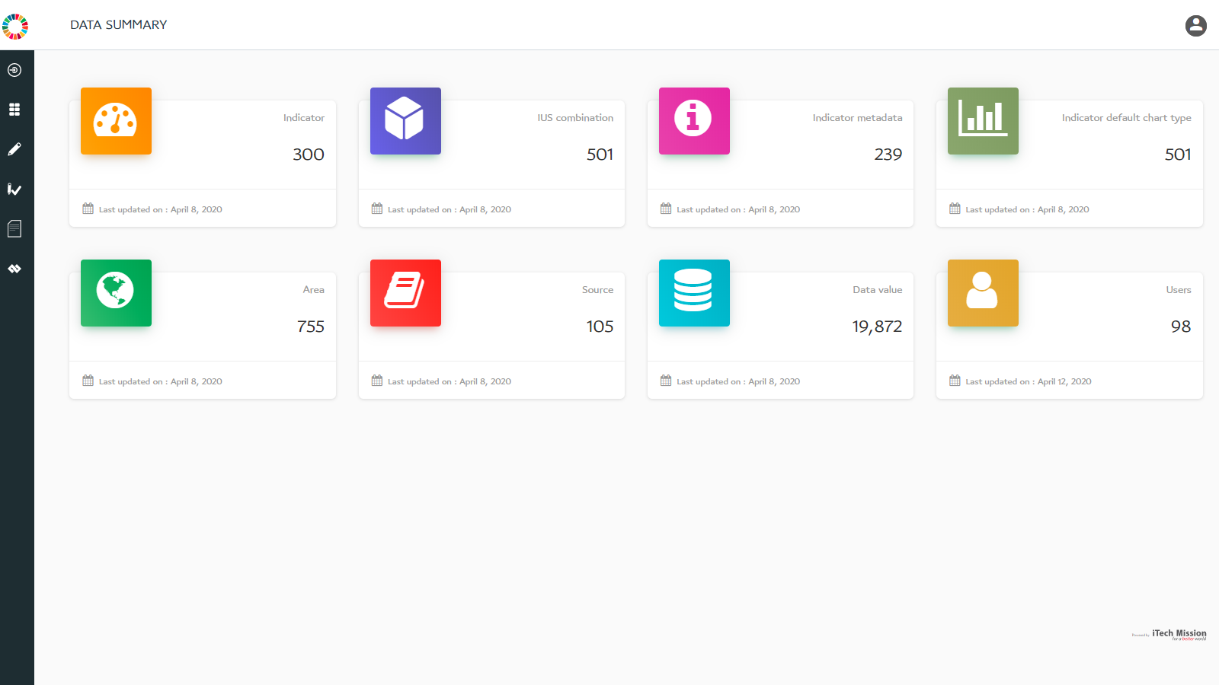Figure 2.1 – Login Page

Figure 2.2 – Data Summary

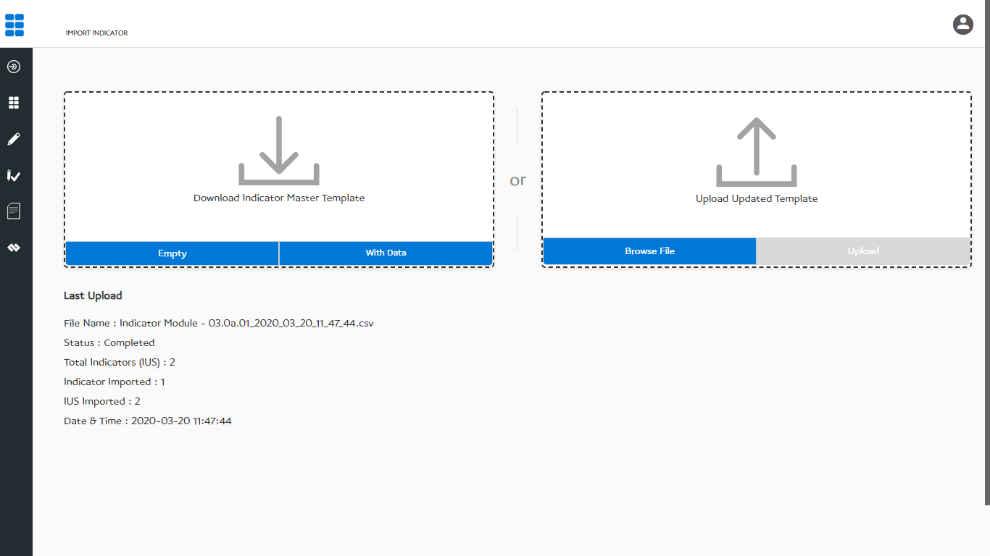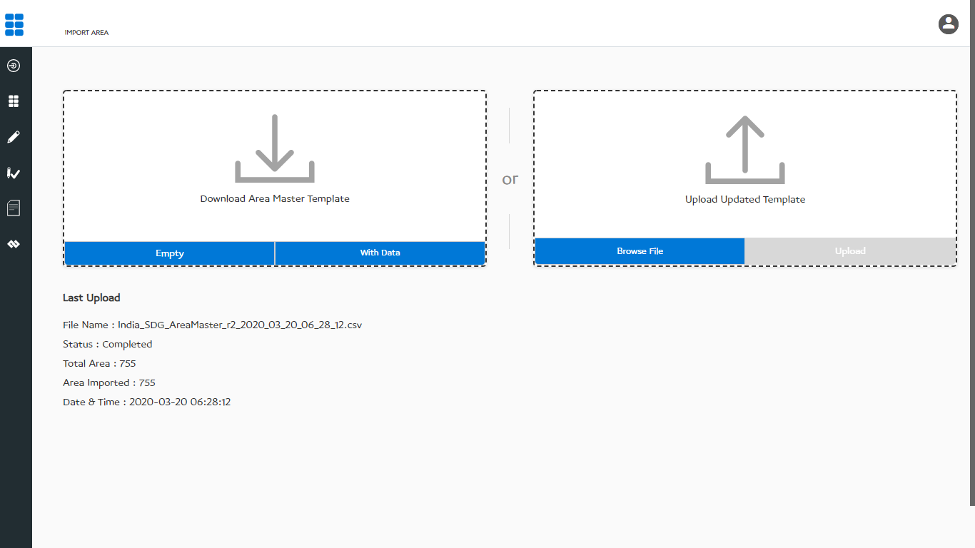Figure 2.3 – Import Area

Figure 2.4 – Import Indicator

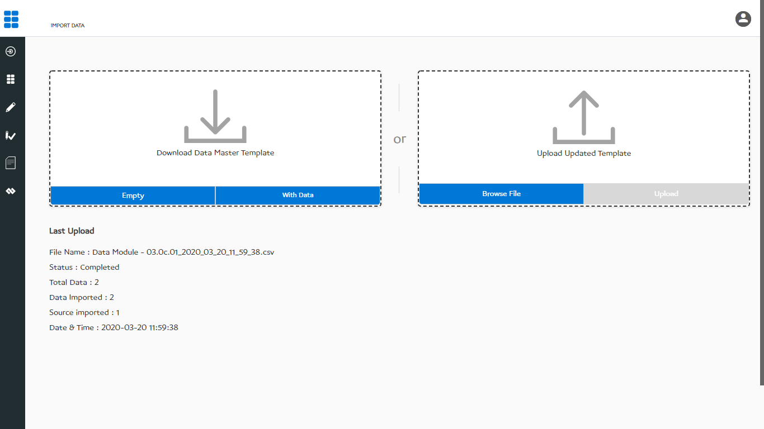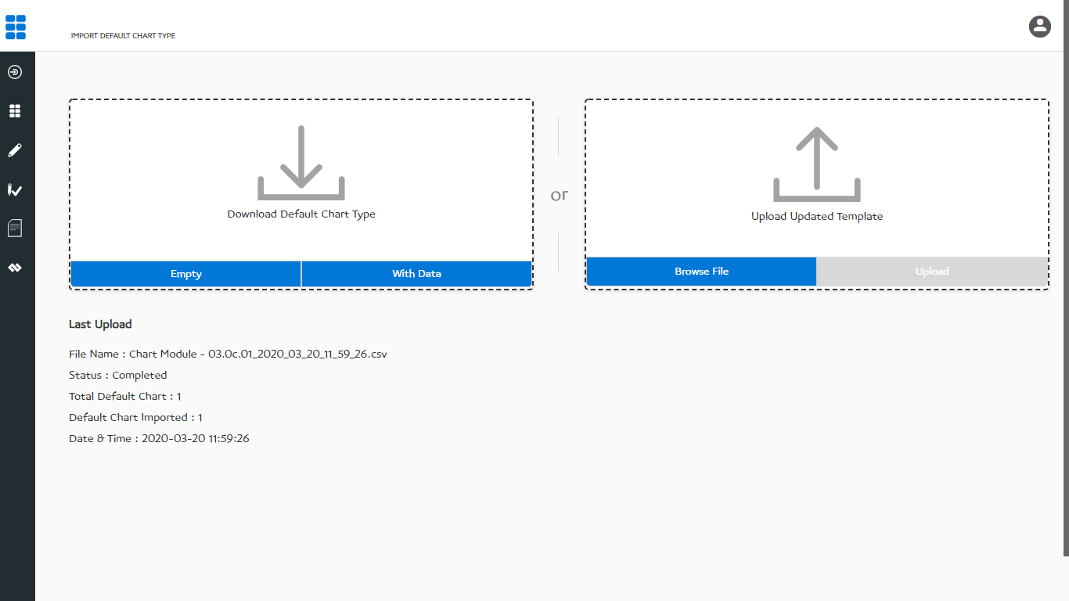Figure 2.5 – Import Chart Template

Figure 2.6 – Import Data

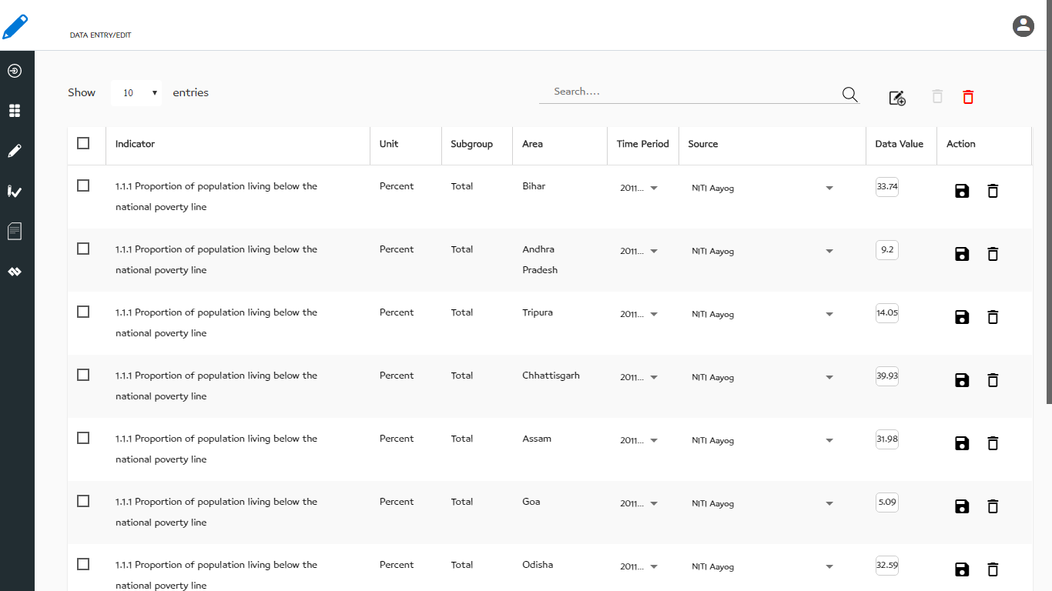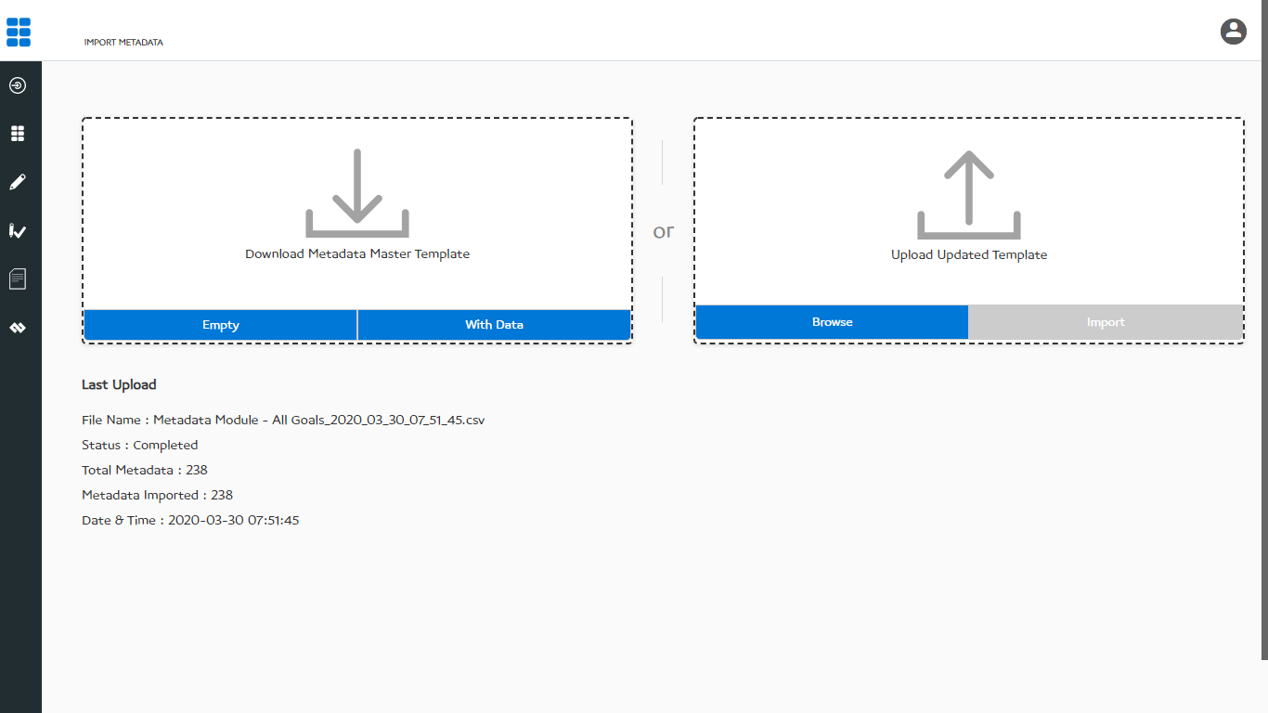Figure 2.7 – Import Metadata

Figure 2.8 – Data Entry / Edit

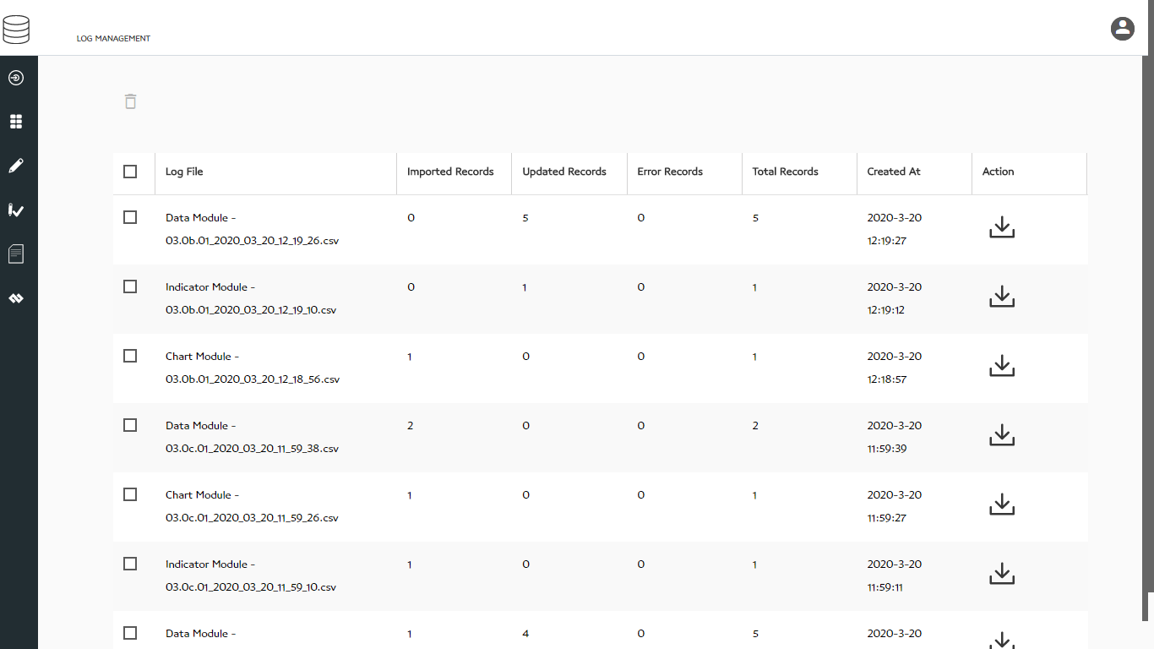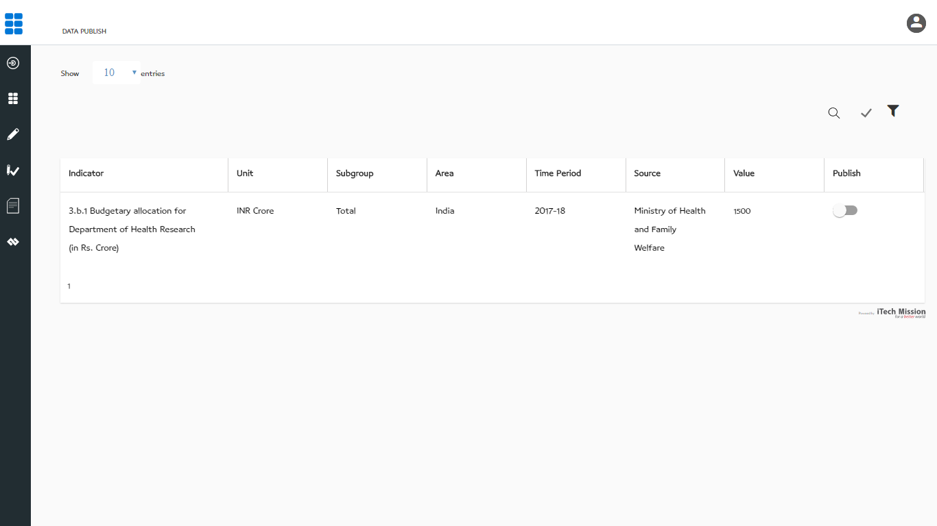Figure 2.9 – Data Approve / Publish

Figure 2.10 – Log

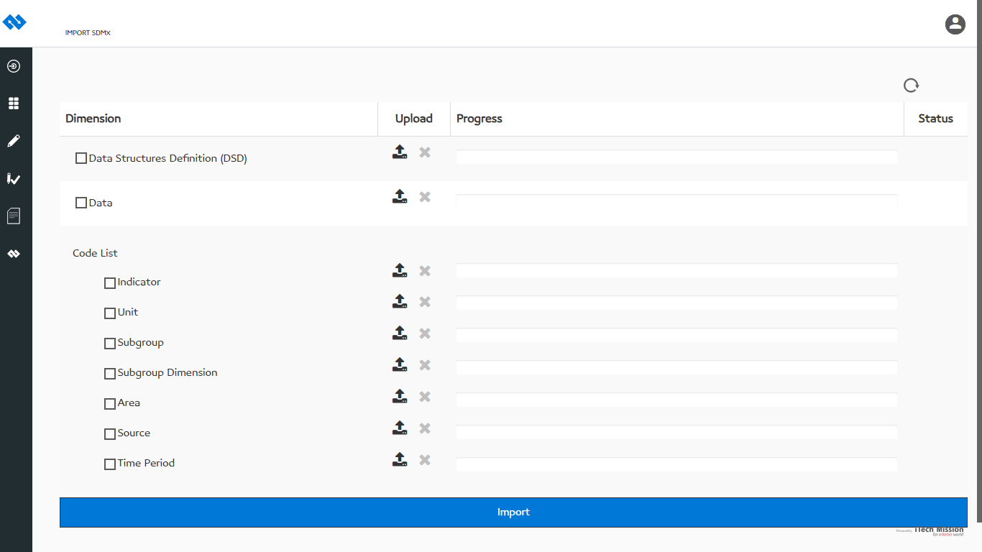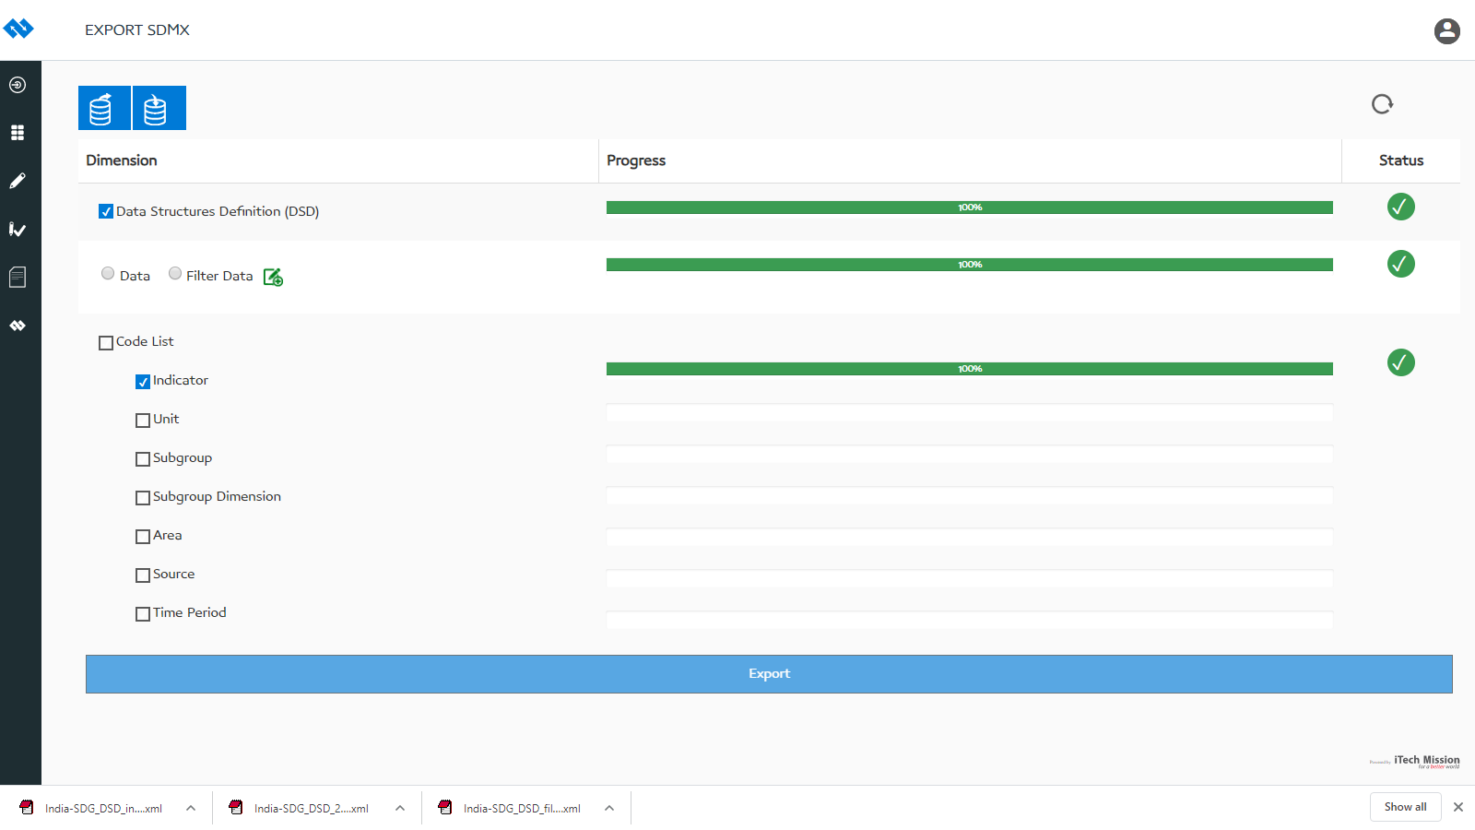Figure 2.11 – Export SDMX

Figure 2.12 – Import SDMX

---- End of the document ----